BAHAUDDIN ZAKARIYA UNIVERSITY, MULTAN
Department of Information Technology
FOURWHEELS
A Full-Stack Web Application for Vehicle Buying, Selling & Inquiry Management
Degree of Bachelor of Science in Information Technology
By
M. Zain Muzaffar
Roll No: RBSIT-21-17
M. Moeez Israr
Roll No: RBSIT-21-12
Session: 2021 – 2025

Supervisor: Mr. Ghulam Ghos

January 2026
Certificate of Approval
This is to certify that the project titled "FOURWHEELS" submitted by M. Zain Muzaffar (Roll No: RBSIT-21-17) & M. Moeez Israr (Roll No: RBSIT-21-12) in partial fulfillment of the requirements for the degree of Bachelor of Science in Information Technology has been examined and approved.

Name: Mr. Ghulam Ghos
Signature: _______________
Date: ___________________

Name: Dr. Maroof Pasha
Signature: ______________
Date: __________________

Declaration
We hereby declare that this project titled "FOURWHEELS" is our own work and has not been submitted elsewhere for any other degree or qualification

Name: M. Zain Muzaffar Name: M. Moeez Israr
Roll No: RBSIT-21-17 Roll No: RBSIT-21-12
Signature: _____________ Signature: _____________
Date: _________________ Date: _________________
Acknowledgements
All praise, thanks, glorification, and gratitude are for ALLAH Almighty. We achieved our goal by ALLAH’s infinite mercy and grace. We say Alhamdulillah for HIS uncountable blessings. After ALLAH, thanks to last Prophet Muhammad (ﷺ) who guided us toward the right path. Beloved prophet (ﷺ) says “Education is equally important for men and women”.
Very special and humble thanks to my father. He is my main supporter to continue the studies. My father instilled iron determination in me. I just want to say, he is great, he is genius. I also express special thanks to my mother. She always prayed for me and improves my confidence to continue the higher study. My mother has always been very caring about my health, studies, and career. I would like to pay my heartiest gratitude to my sister and brothers for being a great source of support and encouragement to complete this work. Especially, thanks to my brothers who guided and helped me all along the way.
I would like to express my sincere gratitude to my supervisor Mr. Ghulam Ghos for the continuous support of my research work, for their patience, motivation, enthusiasm, and immense knowledge. Their guidance helped me during all the time of research and writing of this thesis. I could not have imagined having a better advisor and mentor for my research work.
Secondly, I would like to say thanks to Mam Aliya Bodla, principle and director of Regional Institute of Allied Health Sciences and Higher Education, Mian Channu, whose support and concern towards students is highly valuable.
In addition, I would like to acknowledge important role of Mr. Usman, whose help and assistance remained a source of motivation for me throughout this task.

M. Zain Muzaffar (RBSIT-21-17)
M. Moeez Israr (RBSIT-21-12)
Abstract
Vehicle buying and selling in Pakistan is largely dependent on generic classified platforms or basic listing-based marketplaces, which offer limited visual representation, weak seller verification, and no direct communication channel between buyers and sellers. This often forces buyers to physically inspect vehicles before making informed decisions, resulting in a time-consuming and inefficient process.
FourWheels is a full-stack web-based vehicle marketplace developed to address these limitations by providing a secure, role-based platform for Buyers, Sellers, and Admins. The system's key distinguishing feature is an integrated Three.js-based 3D vehicle viewer, allowing sellers to upload .glb/.gltf models so buyers can interactively rotate, zoom, and inspect vehicles in fullscreen mode—offering a significantly richer experience than static images. The platform further includes a real-time inquiry/messaging module for direct buyer-seller communication and a review and rating system to establish seller credibility.
The backend is built using Node.js and Express.js, with MongoDB and Mongoose for data persistence. Authentication is secured through JWT and bcrypt password hashing, while Multer handles image and 3D model uploads. The frontend, developed in HTML5, CSS3, and vanilla JavaScript, provides dedicated dashboards for each role—including a Seller dashboard for listing management, an Admin panel with Chart.js-based analytics and moderation controls, and a Buyer interface with advanced search, filtering, and sorting capabilities.
An approval-based moderation workflow ensures only verified listings are publicly visible, while functional and security testing validated the system's reliability and usability. The results demonstrate that FourWheels effectively bridges the gap left by existing platforms, delivering a unified, transparent, and interactive vehicle marketplace solution. Future enhancements may include payment gateway integration, a dedicated mobile application, and AI-driven price recommendation.

TABLE OF CONTENTS
CHAPTER 1: INTRODUCTION 14
1.1 Project Overview 14
1.2 Problem Statement 14
1.3 Project Motivation 15
1.4 Aims and Objectives 15
1.4.1 Specific Objectives 15
1.4.2 Objectives Summary Table 16
1.5 Project Scope 17
1.5.1 In Scope 17
1.5.2 Out of Scope 17
1.6 Document Structure 18
CHAPTER 2: LITERATURE REVIEW & BACKGROUND STUDY 20
2.1 Introduction to Domain 20
2.2 Existing Systems Analysis 21
2.2.1 PakWheels 21
2.2.2 OLX Pakistan 21
2.2.3 CarDekho (India) 22
2.2.4 Global Comparator: AutoTrader (UK) 22
2.3 Comparative Analysis of Existing Systems 22
2.4 Identified Research Gaps 24
2.5 Proposed Solution Overview 24
2.6 Summary of Related Background Research 25
CHAPTER 3: REQUIREMENT ANALYSIS & SPECIFICATION 27
3.1 Introduction to Requirements 27
3.2 Stakeholder Analysis 27
3.2.1 Primary Stakeholders 27
3.2.2 Secondary Stakeholders 27
3.3 Functional Requirements 27
3.3.1 User Authentication Module 27
3.3.2 Vehicle Listing Management Module 28
3.3.3 Inquiry / Messaging Module 29
3.3.4 Admin Panel Module 30
3.3.5 Review & Rating Module 30
3.4 Non-Functional Requirements 31
3.5 Use Case Modeling 32
3.5.1 System Level Use Case 32
3.5.2 Authentication Use Case 33
3.5.3 Vehicle Management Use Case 34
3.5.4 Messaging Use Case 35
3.6 User Stories 35
3.7 Hardware and Software Requirements 36
3.7.1 Hardware Requirements 36
3.7.2 Software and Technology Stack 37
CHAPTER 4: SYSTEM DESIGN 40
4.1 Design Principles and Methodology 40
4.2 System Architecture 40
4.2.1 High-Level Architecture 40
4.2.2 Directory Structure 42
4.3 Database Design 42
4.3.1 Collections Overview 42
4.3.2 User Schema 43
4.3.3 Vehicle Schema 43
4.3.4 Message Schema 44
4.3.5 Database Indexes 44
4.4 API Design 45
4.4.1 Authentication API 45
4.4.2 Vehicle API 45
4.4.3 Message API 46
4.4.4 Review API 47
4.5 Process Design 47
4.5.1 DFD Level 0 — Context Diagram 47
4.5.2 DFD Level 1 47
4.5.3 JWT Authentication Flow 48
4.5.4 Add Vehicle Sequence Diagram 48
4.5.5 Inquiry Send Sequence Diagram 49
4.5.6 User Login Sequence Diagram 50
4.5.7 Admin Approval Activity Diagram 51
4.6 Security Design 52
4.6.1 Authentication Security 53
4.6.2 Authorization Security 53
4.6.3 Input Validation 53
4.7 UI/UX Design 53
4.7.1 Design System 53
4.7.2 Key UI Pages 54
CHAPTER 5: IMPLEMENTATION & DEVELOPMENT 55
5.1 Development Environment Setup 55
5.1.1 NPM Dependencies 55
5.1.2 Environment Configuration 56
5.2 Module Implementation 56
5.2.1 Authentication Module 56
5.2.2 Vehicle Management Module 57
5.2.3 Three.js 3D Viewer Implementation 59
5.2.4 Messaging Module 60
5.2.5 Review & Rating Module 61
5.2.6 Admin Dashboard Module 61
5.3 Key Code Explanations 61
5.3.1 Dynamic Filter Builder in getVehicles 61
5.3.2 Optional Authentication Middleware 62
5.4 Frontend Implementation 62
5.5 API Integration Between Frontend and Backend 62
5.6 Database Integration 62
5.7 Challenges Faced and Solutions 63
CHAPTER 6: TESTING & VALIDATION 64
6.1 Testing Strategy 64
6.2 Test Environment 64
6.3 Unit Testing 64
6.3.1 Authentication Functional Test Cases 64
6.3.2 Vehicle CRUD Test Cases 65
6.4 Integration Testing 67
6.5 Functional Test Cases and Results 67
6.6 Security Testing 68
6.7 Performance Testing 68
6.8 UI and Usability Testing 69
6.9 Bug Report and Resolution 70
6.10 Testing Summary 71
CHAPTER 7: RESULTS & DISCUSSION 72
7.1 System Implementation Results 72
7.1.1 Home Page 72
7.1.2 Authentication Pages 73
7.1.3 Browse Vehicles Page 74
7.1.4 Vehicle Detail Page 74
7.1.5 Seller Dashboard 75
7.1.6 Buyer Messages Page 75
7.1.7 Admin Dashboard 75
7.1.8 Seller Reviews 76
7.2 Achievement of Objectives 76
7.3 Gap Resolution Assessment 77
7.4 Performance Evaluation 77
7.5 Discussion 77
7.6 Limitations Encountered 78
CHAPTER 8: CONCLUSION & FUTURE WORK 79
8.1 Conclusion 79
8.2 Limitations 79
8.3 Future Enhancements 80
8.3.1 Short-Term Enhancements (Phase 2) 80
8.3.2 Medium-Term Enhancements (Phase 3) 80
8.3.3 Long-Term Enhancements (Phase 4) 80
8.4 Social Impact and Applications 81
REFERENCES 81
APPENDIX 82
Appendix A - Installation and Setup Guide 82
A.1 Prerequisites 82
A.2 Installation Steps 82
A.3 Test Accounts (After Seeding) 82
Appendix B - API Endpoint Reference 83
Appendix C - Database Schema Reference 83

LIST OF TABLES
Table 1.1 - Project Objectives Summary
Table 1.2 - Project Scope Summary
Table 2.1 - Existing Platforms Feature Comparison
Table 2.2 - Identified Research Gaps
Table 2.3 - Background Research Summary
Table 3.1 - User Authentication Functional Requirements
Table 3.2 - Vehicle Listing Management Requirements
Table 3.3 - Inquiry/Messaging Requirements
Table 3.4 - Admin Panel Functional Requirements
Table 3.5 - Review & Rating Module Requirements
Table 3.6 - Non-Functional Requirements
Table 3.7 - User Stories
Table 3.8 - Hardware Requirements
Table 3.9 - Software and Technology Stack
Table 4.1 - Database Collections & Schemas
Table 4.2 - Database Indexes
Table 4.3 - Authentication API Endpoints
Table 4.4 - Vehicle API Endpoints
Table 4.5 - Message API Endpoints
Table 4.6 - Review API Endpoints
Table 4.7 - Admin API Endpoints
Table 5.1 - Development Tools and Versions
Table 5.2 - NPM Dependencies
Table 5.3 - Challenges Faced and Solutions
Table 6.1 - Authentication Functional Test Cases
Table 6.2 - Vehicle CRUD Test Cases
Table 6.3 - Messaging System Test Cases
Table 6.4 - Admin Panel Test Cases
Table 6.5 - Security Test Cases
Table 6.6 - API Performance Results
Table 6.7 - UI Usability Test Cases
Table 6.8 - Bug Report and Resolution Log
Table 6.9 - Testing Summary
Table 7.1 - Objectives Achievement Matrix

LIST OF FIGURES
Figure 1.1 - Document Structure Flow Diagram
Figure 2.1 - Online Vehicle Marketplace Evolution Timeline
Figure 2.2 - Existing Platforms Feature Comparison Chart
Figure 2.3 - Research Gap to Solution Mapping
Figure 3.1 - System Level Use Case Diagram
Figure 3.2 - Authentication Use Case Diagram
Figure 3.3 - Vehicle Management Use Case Diagram
Figure 3.4 - Messaging Use Case Diagram
Figure 3.5 - Technology Stack Architecture Diagram
Figure 4.1 - High Level System Architecture Diagram
Figure 4.2 - Three Tier Architecture Diagram
Figure 4.3 - User Schema Document Structure
Figure 4.4 - Vehicle Schema Document Structure
Figure 4.5 - Message Schema Document Structure
Figure 4.6 - JWT Authentication Flow Diagram
Figure 4.7 - API Response Structure Diagram
Figure 4.8 - DFD Level 0 Context Diagram
Figure 4.9 - DFD Level 1 Diagram
Figure 4.10 - Add Vehicle Sequence Diagram
Figure 4.11 - Inquiry Send Sequence Diagram
Figure 4.12 - User Login Sequence Diagram
Figure 4.13 - Admin Approval Activity Diagram
Figure 4.14 - Home Page UI Design
Figure 4.15 - Browse Vehicles Page Design
Figure 4.16 - Vehicle Detail Page Design
Figure 4.17 - Seller Dashboard Design
Figure 4.18 - Admin Dashboard Design
Figure 5.1 - Project Directory Structure
Figure 5.2 - Authentication Module Implementation Diagram
Figure 5.3 - Vehicle Controller Function Map
Figure 5.4 - 3D Model Viewer Integration Flow
Figure 5.5 - JWT Token Generation Code Snippet
Figure 5.6 - Role-Based Access Control Code Snippet
Figure 5.7 - Multer File Upload Configuration Snippet
Figure 7.1 - Home Page Screenshot
Figure 7.2 - Register Page Screenshot
Figure 7.3 - Login Page Screenshot
Figure 7.4 - Browse Vehicles Page Screenshot
Figure 7.5 - Vehicle Detail Page Screenshot
Figure 7.6 - 3D Viewer Screenshot
Figure 7.7 - Seller Dashboard Screenshot
Figure 7.8 - Add Vehicle Form Screenshot
Figure 7.9 - Buyer Messages Page Screenshot
Figure 7.10 - Admin Dashboard Screenshot
Figure 7.11 - Admin Users Management Screenshot
Figure 7.12 - Seller Reviews & Ratings Screenshot

CHAPTER 1: INTRODUCTION

1.1 Project Overview
FourWheels is a full-stack, web-based vehicle marketplace designed specifically for Pakistan's rapidly growing automotive digital economy. The platform connects vehicle buyers and sellers across the country by providing a modern, intuitive, and feature-rich environment for listing, browsing, and inquiring about vehicles. The system supports three primary user roles buyers, sellers, and administrators each with a distinct interface and set of capabilities.
The platform enables sellers to list vehicles complete with images and optional 3D model previews using the Three.js library, which is a significant differentiator from existing platforms. Buyers can browse listings with advanced filtering by city, price range, and category (cars, bikes, and trucks), and can send direct inquiry messages to sellers. Administrators are provided a powerful dashboard that includes analytics charts, user management with block/unblock controls, and vehicle approval/rejection workflows.
The application is built using a modern technology stack comprising Vanilla JavaScript, HTML5, and CSS3 on the frontend, and Node.js with Express.js v5 on the backend, with MongoDB as the primary database via the Mongoose ODM. File uploads are handled using Multer, with support for JPEG/PNG image uploads and GLB/GLTF 3D model files. Authentication is implemented using JSON Web Tokens (JWT) with bcrypt password hashing.

1.2 Problem Statement
Pakistan's vehicle marketplace is dominated by informal buying and selling channels word of mouth, physical dealerships, and fragmented social media groups. While a few online platforms exist (such as PakWheels and OLX), they suffer from several critical limitations that create friction for both buyers and sellers:
- Lack of visual richness: Existing platforms rely solely on 2D images, giving buyers a limited understanding of the vehicle's condition and appearance.
- Poor inquiry management: Buyers often communicate through phone numbers listed publicly, leading to privacy concerns and no centralized message tracking.
- No role-based access control: There is no structured differentiation between buyer and seller accounts, leading to misuse and spam listings.
- Absence of seller trust indicators: Buyers have no way to assess seller credibility through a review and rating system on existing local platforms.
- Limited administrative oversight: Platform administrators lack real-time analytics, approval workflows, and user management tools to maintain listing quality.
- No 3D preview technology: No local vehicle marketplace offers 3D model previews of vehicles, a technology that significantly enhances buyer confidence.
These gaps result in a frustrating user experience, reduced transaction confidence, and a generally inefficient marketplace. FourWheels was conceived to address all of these problems with a single, cohesive platform.

1.3 Project Motivation
The primary motivation behind FourWheels stems from observing the rapid growth of Pakistan's used vehicle market alongside the digital transformation of consumer behavior. According to industry trends, Pakistan has one of the largest two-wheeler and compact car markets in South Asia, yet digital vehicle commerce remains underdeveloped compared to regional peers.
As Final Year Project students with a background in web development, the team was motivated by the opportunity to build a technically challenging, socially relevant, and commercially viable platform. The inclusion of Three.js-based 3D vehicle preview technology provided a strong technical research component, as integrating real-time 3D rendering into a web marketplace was a novel challenge not attempted by existing Pakistani platforms.
Furthermore, building a full-stack system with a complete CRUD API, JWT-based authentication, role-based access control, file upload management, real-time messaging, seller reviews, and an admin analytics dashboard provided comprehensive coverage of advanced web development concepts relevant to the final year curriculum.

1.4 Aims and Objectives
The primary aim of FourWheels is to build a fully functional, production-quality vehicle marketplace web application for Pakistan that significantly improves upon existing platforms through modern technology and thoughtful UX design.

1.4.1 Specific Objectives
- Design and implement a secure user authentication system with role-based access control (buyer, seller, admin).
- Build a complete vehicle listing management system supporting multiple image uploads and optional 3D GLB/GLTF model files.
- Develop a real-time 3D vehicle preview using the Three.js library, including a fullscreen interactive viewer with drag-rotate and zoom controls.
- Implement a direct messaging/inquiry system between buyers and sellers, with conversation threading and unread message tracking.
- Create a seller review and star-rating system with an animated speedometer UI for rating visualization.
- Build a comprehensive admin dashboard with user management (block/unblock/delete), vehicle approval workflows, and Chart.js analytics.
- Implement advanced vehicle search and filtering by title, city, price range, category, and sort options with server-side pagination.
- Ensure the application is responsive, accessible, and compatible with modern browsers on desktop and mobile.

1.4.2 Objectives Summary Table
Table 1.1 - Project Objectives Summary
# | Objective | Module | Priority
1 | Secure authentication with JWT & bcrypt | Auth System | Critical
2 | Vehicle listing with multi-image upload | Listings | Critical
3 | 3D vehicle preview with Three.js | 3D Viewer | High
4 | Buyer-seller messaging system | Messaging | High
5 | Seller review & rating system | Reviews | Medium
6 | Admin dashboard with analytics | Admin Panel | High
7 | Advanced search & filter with pagination | Search/Filter | High
8 | Responsive UI for desktop and mobile | Frontend | Medium

1.5 Project Scope
FourWheels is scoped as a web-based application accessible through modern desktop and mobile browsers. The following defines what is included and excluded from the project scope.

1.5.1 In Scope
- User registration, login, and profile management for three roles: buyer, seller, and admin.
- Vehicle listings supporting cars, bikes, and trucks with multi-image and 3D model uploads.
- Browse, search, filter, and sort vehicle listings with server-side pagination.
- Vehicle detail page with image gallery, Three.js 3D interactive viewer, seller info, and inquiry form.
- Direct messaging system between buyers and sellers with conversation threads.
- Seller rating and review system with star inputs and animated speedometer visualization.
- Admin panel with user management, vehicle approval workflows, and analytics charts.
- Seller dashboard for listing management (add, edit, delete) and message inbox.
- Buyer messages page for viewing and replying to inquiry threads.
- Seed data script for sample users and vehicles.
- 404 error page and toast notification system throughout the application.

1.5.2 Out of Scope
- Real-time chat using WebSockets (polling-based refresh is used instead).
- Native mobile application (iOS/Android).
- Payment gateway integration or transaction processing.
- Email notification system.
- Advanced fraud detection or AI-powered content moderation.
- Multi-language support (Urdu localization).

Table 1.2 - Project Scope Summary
Feature Area | Included | Notes
Authentication & Roles | Yes | Buyer, Seller, Admin with JWT
Vehicle CRUD | Yes | Multi-image + 3D model upload
3D Viewer | Yes | Three.js r128 with GLTFLoader
Messaging | Yes | Polling-based, not WebSocket
Reviews & Ratings | Yes | Per seller, 1-5 stars
Admin Dashboard | Yes | Charts, user mgmt, approvals
Payment Gateway | No | Out of scope for FYP
Mobile App | No | Responsive web only
Email Notifications | No | Out of scope for FYP
Real-time WebSockets | No | 5-second polling used

1.6 Document Structure
This document is organized into eight chapters, each covering a distinct phase of the software development lifecycle as applied to the FourWheels project.
- Chapter 1 - Introduction: Provides the project overview, problem statement, motivation, objectives, and scope.
- Chapter 2 - Literature Review & Background Study: Surveys existing vehicle marketplace platforms and identifies research gaps that FourWheels addresses.
- Chapter 3 - Requirement Analysis & Specification: Details functional and non-functional requirements, use cases, user stories, and hardware/software specifications.
- Chapter 4 - System Design: Covers architecture, database design, API design, process flows, security design, and UI/UX wireframes.
- Chapter 5 - Implementation & Development: Documents the development environment, module-by-module implementation, key code explanations, and challenges faced.
- Chapter 6 - Testing & Validation: Presents the testing strategy, test cases, results, security testing, performance benchmarks, and bug resolution log.
- Chapter 7 - Results & Discussion: Shows screenshots of the working system, evaluates objective achievement, and discusses performance and limitations.
- Chapter 8 - Conclusion & Future Work: Summarizes findings, acknowledges limitations, and proposes future enhancements.

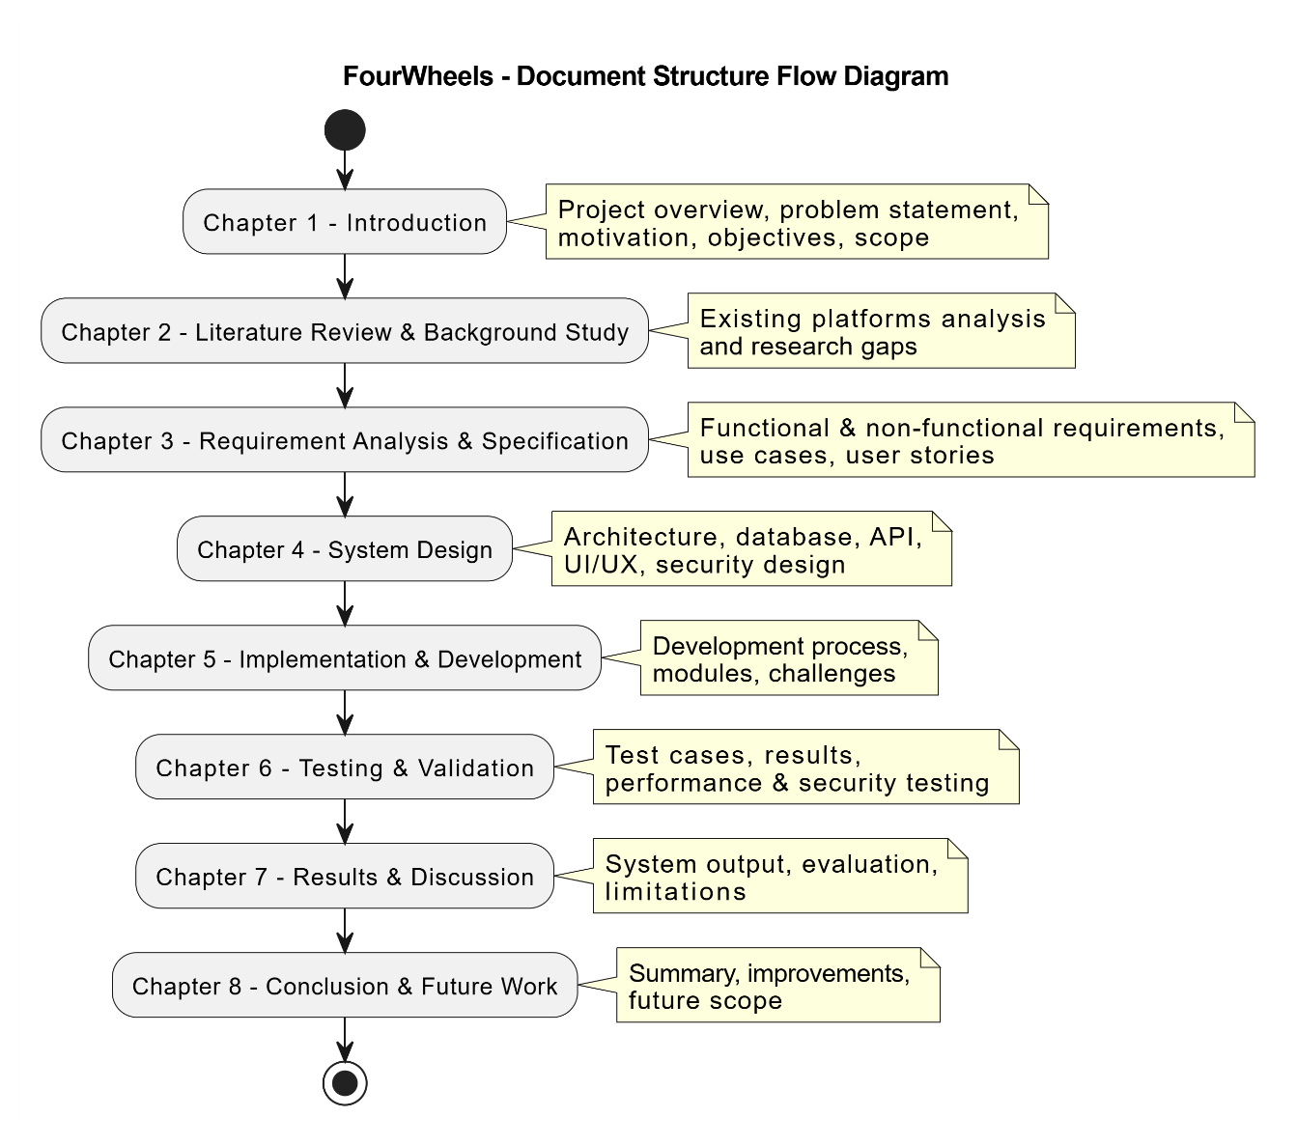

CHAPTER 2: LITERATURE REVIEW & BACKGROUND STUDY

2.1 Introduction to Domain
The online vehicle marketplace domain refers to digital platforms that facilitate the buying, selling, and trading of automobiles, motorcycles, and commercial vehicles through web-based or mobile applications. These platforms have grown substantially over the past two decades, transitioning from simple classified advertisement websites to sophisticated ecosystems featuring AI-powered recommendations, virtual test drives, and integrated financing options.
In Pakistan specifically, the digital vehicle trade is a nascent but rapidly growing segment. The country has approximately 6 million registered vehicles with several hundred thousand transactions occurring annually in the used vehicle segment. The primary digital touchpoints for these transactions currently include dedicated classifieds platforms such as PakWheels, general classifieds like OLX, and informal Facebook Marketplace groups. However, these platforms have not kept pace with global trends in vehicle marketplace technology.
Globally, platforms like AutoTrader (UK), Cars.com (USA), and CarDekho (India) have invested heavily in immersive vehicle visualization, AI chatbots for buyer assistance, and verified seller programs. The gap between global standards and Pakistani platform capabilities represents a clear opportunity for innovation.

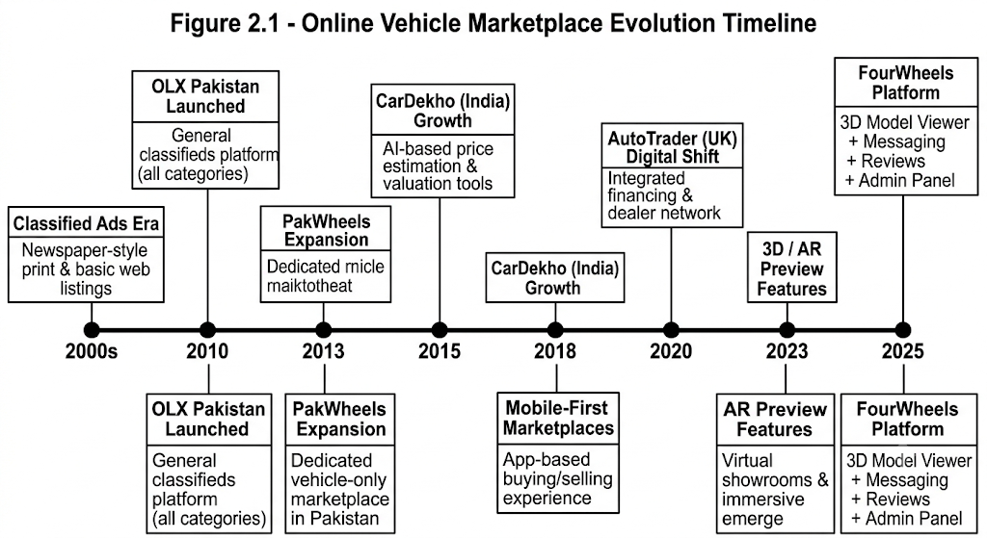

2.2 Existing Systems Analysis

2.2.1 PakWheels
PakWheels is the most established vehicle marketplace in Pakistan, launched in 2003. It offers classified listings for cars, bikes, and buses with features including user registration, image uploads, price comparisons, and a car review section. However, the platform's user interface has not significantly modernized in recent years. The listing experience is complex for new users, there is no real-time messaging system (communication is via exposed phone numbers), and no seller reputation system built on verified transactions. The platform also lacks 3D visualization capabilities.

2.2.2 OLX Pakistan
OLX is a general-purpose classified platform used extensively for vehicle listings in Pakistan. While it benefits from a large user base and a clean mobile application, it is not specialized for vehicles. It lacks features such as vehicle-specific filtering (engine type, mileage, registration year), dedicated seller profiles for vehicle dealers, and any form of review or trust system. Messages are handled through the OLX internal chat but lack the threading and vehicle-context features that a dedicated platform would provide.

2.2.3 CarDekho (India)
CarDekho represents a more technologically advanced regional comparator. It features AI-powered car valuations, 360-degree interior views, financing calculators, and verified seller badges. The platform's review system allows both dealer and user reviews, contributing to buyer confidence. However, it is not available in Pakistan and does not support the two-wheeler and commercial vehicle segments as robustly as the Pakistani market requires.

2.2.4 Global Comparator: AutoTrader (UK)
AutoTrader UK is widely regarded as the gold standard for online vehicle marketplaces. It features advanced search with over 20 filter parameters, dealer locator maps, finance calculators, and immersive image galleries. While it does not yet offer real-time 3D model viewing, it represents the UX benchmark that FourWheels aspires to match or exceed within the Pakistani context.

2.3 Comparative Analysis of Existing Systems
Table 2.1 - Existing Platforms Feature Comparison
Feature | PakWheels | OLX Pak | CarDekho | FourWheels
Role-Based Accounts | Partial | No | Yes | Yes
3D Model Preview | No | No | No | Yes
Direct Messaging | No | Yes | Yes | Yes
Seller Review System | No | No | Yes | Yes
Admin Approval Workflow | No | No | Yes | Yes
Advanced Search Filters | Partial | Basic | Yes | Yes
Mobile Responsive | Partial | Yes | Yes | Yes
Image Gallery Slider | Yes | Yes | Yes | Yes
Analytics Dashboard | No | No | Yes | Yes
Open Source/FYP | No | No | No | Yes

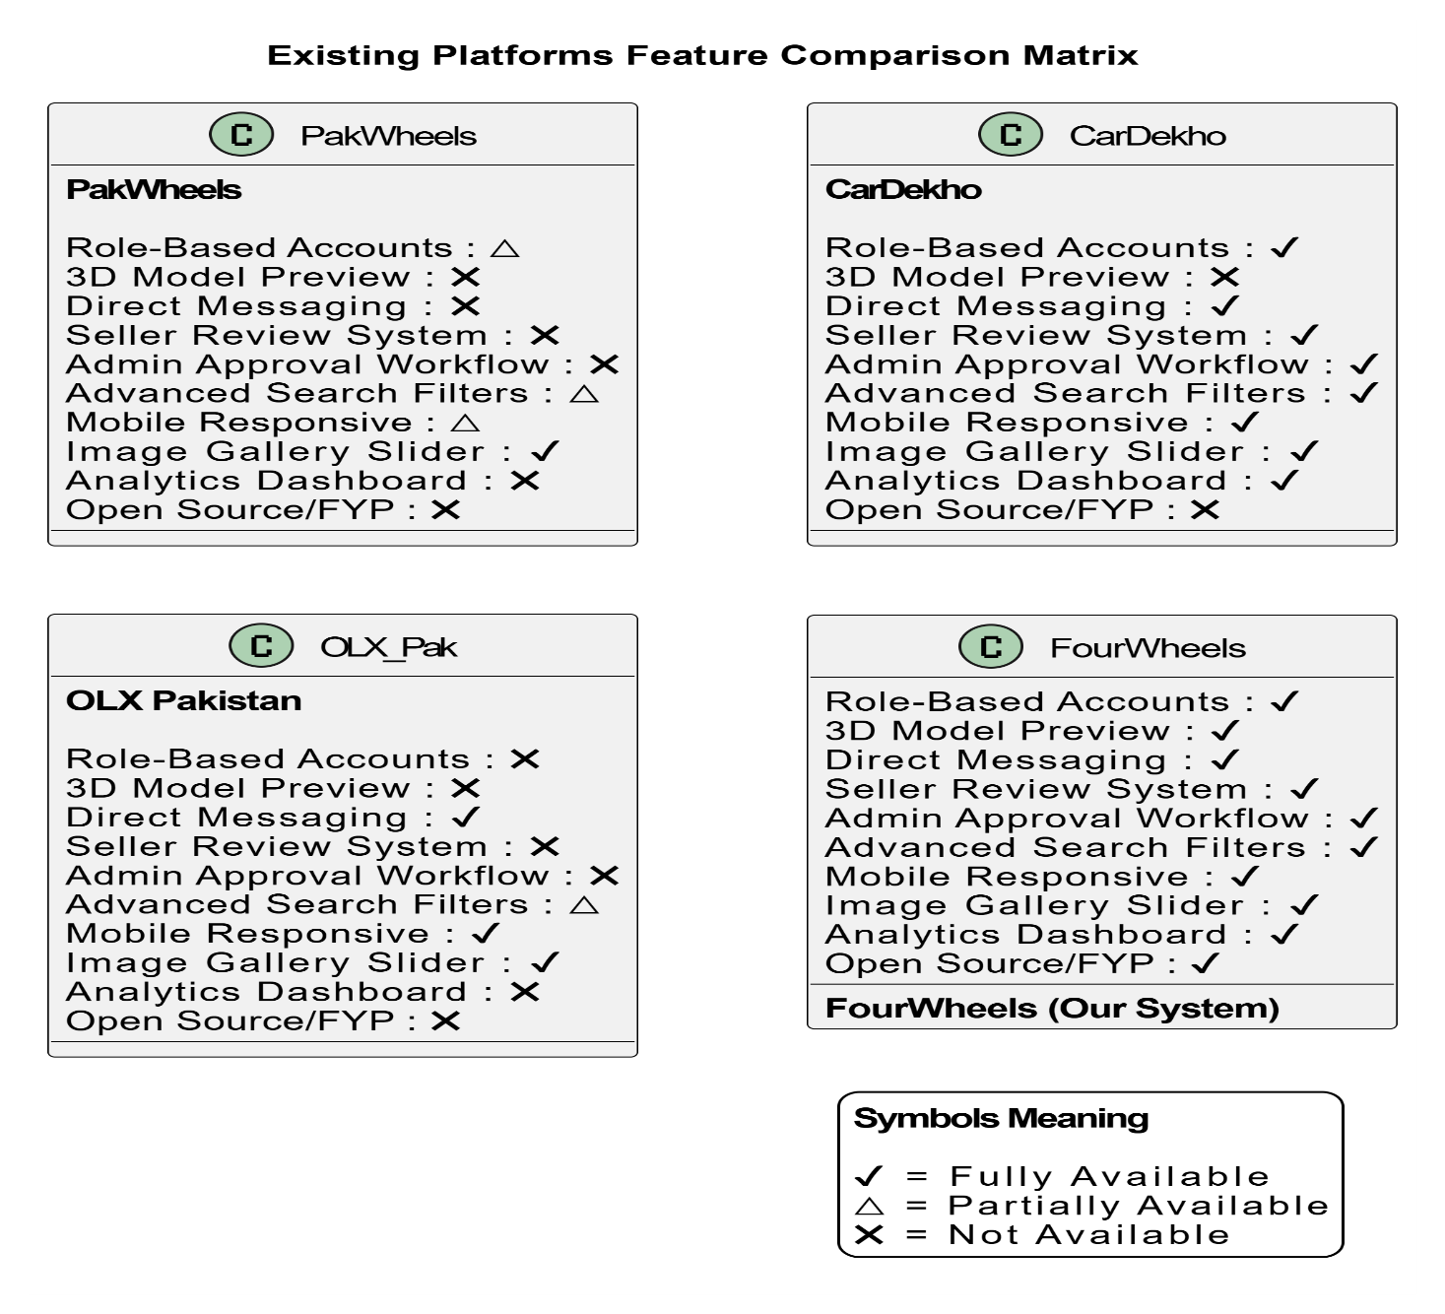

2.4 Identified Research Gaps
The comparative analysis revealed several critical gaps in the existing landscape of Pakistani vehicle marketplaces that FourWheels is specifically designed to address.
Table 2.2 - Identified Research Gaps
Gap # | Identified Gap | Impact | FourWheels Solution
G1 | No 3D vehicle visualization on Pakistani platforms | Low buyer confidence | Three.js GLB/GLTF viewer
G2 | No structured seller trust/reputation system | Fraud risk, mistrust | Star rating & review system
G3 | Lack of centralized in-platform messaging | Communication gaps | Threaded inquiry messaging
G4 | No admin approval workflow for listing quality | Spam & fake listings | Pending/approve/reject pipeline
G5 | Primitive search with minimal filter options | Poor discovery | Multi-param server-side search
G6 | No role separation (buyer vs seller) | Cluttered UX | Distinct role-based dashboards

2.5 Proposed Solution Overview
FourWheels proposes a purpose-built vehicle marketplace that directly addresses each identified gap. The platform introduces 3D vehicle preview technology as a first-of-its-kind feature in the Pakistani market, with Three.js-powered interactive GLB model viewers embedded directly in vehicle detail pages. The seller review system allows buyers to rate and comment on sellers after interactions, building a transparent trust layer. The centralized messaging system provides full thread history per vehicle inquiry. The admin approval pipeline ensures all listings are reviewed before going live, maintaining listing quality. Advanced multi-parameter search with server-side filtering and pagination delivers a discovery experience comparable to international platforms.

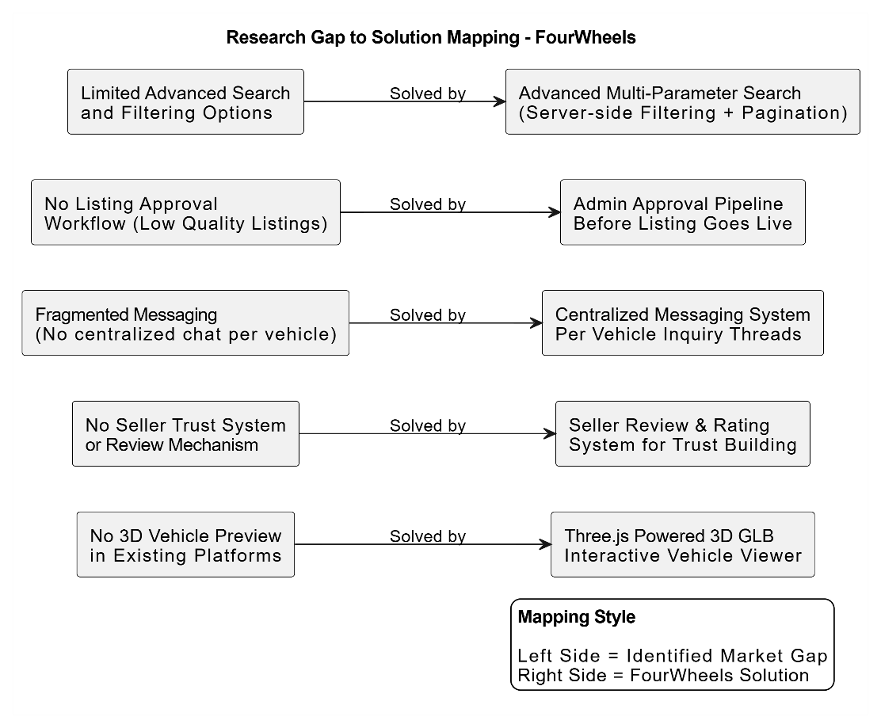

2.6 Summary of Related Background Research
The following table summarizes the key technical concepts and technologies researched during the background study phase to support the design and implementation decisions made in FourWheels.
Table 2.3 - Background Research Summary
Topic | Key Finding | Application in FourWheels
JWT Authentication | Stateless tokens eliminate server-side session storage | Used for all protected API routes
BCrypt Hashing | Work factor of 10 provides strong security with acceptable performance | Password storage at registration
Three.js r128 | GLTFLoader supports GLB/GLTF; OrbitControls removed in newer builds | 3D viewer with custom drag controls
MongoDB Indexing | Compound indexes on frequently queried fields reduce query time by 60-80% | Indexes on category, city, status, price
Multer v2 | diskStorage with dynamic destination enables organized file structure | Separate uploads/images and uploads/models
Chart.js v4 | Doughnut and bar charts with dark theme via custom color config | Admin dashboard analytics
Polling vs WebSockets | For low-frequency updates, 5s polling adds minimal server overhead | Message refresh without WebSocket complexity

CHAPTER 3: REQUIREMENT ANALYSIS & SPECIFICATION

3.1 Introduction to Requirements
This chapter presents the complete requirement specification for FourWheels, covering all stakeholders, functional requirements per module, non-functional requirements, use case models, user stories, and hardware/software specifications. Requirements were gathered through domain analysis of existing Pakistani vehicle platforms, user interviews with potential buyers and sellers, and review of the project objectives defined in Chapter 1.

3.2 Stakeholder Analysis

3.2.1 Primary Stakeholders
- Buyers: Individuals or organizations looking to purchase vehicles. They require a smooth browsing, filtering, and inquiry experience.
- Sellers: Individuals or dealers who wish to list their vehicles for sale. They require an easy listing creation and management dashboard.
- Administrators: Platform operators responsible for maintaining listing quality, managing users, and monitoring platform health.

3.2.2 Secondary Stakeholders
- FYP Evaluation Committee: Academic supervisors and examiners assessing technical quality, documentation, and demonstration.
- System Developers: The development team responsible for building, testing, and maintaining the application.

3.3 Functional Requirements

3.3.1 User Authentication Module
Table 3.1 - User Authentication Functional Requirements
Req ID | Requirement Description | Priority | Actor
FR-A01 | System shall allow new users to register with name, email, password, city, phone, and role (buyer/seller). | Critical | All Users
FR-A02 | System shall hash passwords using bcryptjs with salt factor 10 before storing. | Critical | System
FR-A03 | System shall validate email format and minimum password length (6 chars) on both frontend and backend. | Critical | All Users
FR-A04 | System shall generate a JWT token on successful login with 7-day expiry. | Critical | All Users
FR-A05 | System shall return user role in login response for frontend routing. | Critical | System
FR-A06 | Admin login portal shall deny access to non-admin accounts. | Critical | Admin
FR-A07 | System shall support account blocking by admin; blocked users receive 403 on login. | High | Admin
FR-A08 | System shall provide a GET /api/auth/me endpoint for authenticated users. | High | All Users

3.3.2 Vehicle Listing Management Module
Table 3.2 - Vehicle Listing Management Requirements
Req ID | Requirement Description | Priority | Actor
FR-V01 | Sellers shall be able to create vehicle listings with title, description, price, city, and category. | Critical | Seller
FR-V02 | System shall support upload of up to 10 JPEG/PNG/WEBP images per listing. | Critical | Seller
FR-V03 | System shall support optional upload of one .glb or .gltf 3D model file per listing. | High | Seller
FR-V04 | All new listings shall have status 'pending' by default; they are only visible to admin until approved. | Critical | System
FR-V05 | Buyers and public users shall only see listings with 'approved' status. | Critical | Buyer/Public
FR-V06 | Sellers shall be able to edit and delete their own listings. | High | Seller
FR-V07 | System shall increment view count on each GET /api/vehicles/:id request. | Medium | System
FR-V08 | System shall support filtering by category, city, price range, and search keyword. | High | Buyer/Public
FR-V09 | System shall support sorting by newest, oldest, price ascending, price descending, and most viewed. | Medium | Buyer/Public
FR-V10 | System shall implement server-side pagination with configurable limit (max 50 per page). | High | System

3.3.3 Inquiry / Messaging Module
Table 3.3 - Inquiry/Messaging Requirements
Req ID | Requirement Description | Priority | Actor
FR-M01 | Authenticated buyers shall be able to send inquiry messages about specific vehicle listings. | Critical | Buyer
FR-M02 | Sellers shall be able to view all inquiries about their listings in a threaded conversation view. | Critical | Seller
FR-M03 | Both buyers and sellers shall be able to reply within a conversation thread. | High | Buyer/Seller
FR-M04 | System shall track unread message count per user and display it in navigation. | High | System
FR-M05 | Sellers shall not be able to send inquiry messages about their own listings. | Critical | System
FR-M06 | Messages shall be automatically marked as read when the thread is viewed. | Medium | System
FR-M07 | Buyer messages page shall auto-refresh active thread every 5 seconds. | Medium | Buyer

3.3.4 Admin Panel Module
Table 3.4 - Admin Panel Functional Requirements
Req ID | Requirement Description | Priority | Actor
FR-AD01 | Admin shall be able to view all registered users with pagination and role filtering. | Critical | Admin
FR-AD02 | Admin shall be able to block and unblock user accounts. | Critical | Admin
FR-AD03 | Admin shall be able to permanently delete user accounts (non-admin only). | High | Admin
FR-AD04 | Admin shall be able to approve or reject pending vehicle listings. | Critical | Admin
FR-AD05 | Admin shall be able to delete any vehicle listing regardless of seller. | High | Admin
FR-AD06 | Admin dashboard shall display real-time stats: total users, total listings, pending, approved. | High | Admin
FR-AD07 | Admin dashboard shall render a monthly listings bar chart and a category distribution donut chart. | Medium | Admin

3.3.5 Review & Rating Module
Table 3.5 - Review & Rating Module Requirements
Req ID | Requirement Description | Priority | Actor
FR-R01 | Authenticated buyers shall be able to submit a star rating (1-5) and optional comment for a seller. | High | Buyer
FR-R02 | Each buyer may submit only one review per seller; subsequent submissions update the existing review. | High | System
FR-R03 | System shall compute and display average seller rating with a rating bar distribution. | High | System
FR-R04 | Reviewers and admins shall be able to delete reviews. | Medium | Buyer/Admin
FR-R05 | Star selection shall trigger an animated speedometer visualization for user engagement. | Low | System

3.4 Non-Functional Requirements
Table 3.6 - Non-Functional Requirements
Category | Requirement | Metric/Target
Performance | API response time for GET /api/vehicles shall be under 500ms for up to 1000 records. | < 500ms
Security | All protected routes shall require valid JWT Bearer token; unauthorized requests return 401. | 100% enforced
Security | Passwords shall be hashed with bcrypt, never stored in plain text. | Zero plaintext passwords
Reliability | Server shall handle uncaught Multer errors with appropriate HTTP 400 responses. | Graceful error handling
Scalability | Pagination shall be implemented server-side to support large listing volumes. | Server-side pagination
Usability | Application shall be fully functional on screen widths from 375px (mobile) to 1440px (desktop). | Responsive at 375px+
Maintainability | Backend code shall be organized in MVC pattern with separate controllers, routes, and middleware. | MVC architecture
Compatibility | Frontend shall function correctly in Chrome (v90+), Firefox (v88+), and Edge (v90+). | 3 major browsers
Data Integrity | Vehicle deletion shall also delete associated uploaded image and model files from disk. | No orphaned files

3.5 Use Case Modeling

3.5.1 System Level Use Case
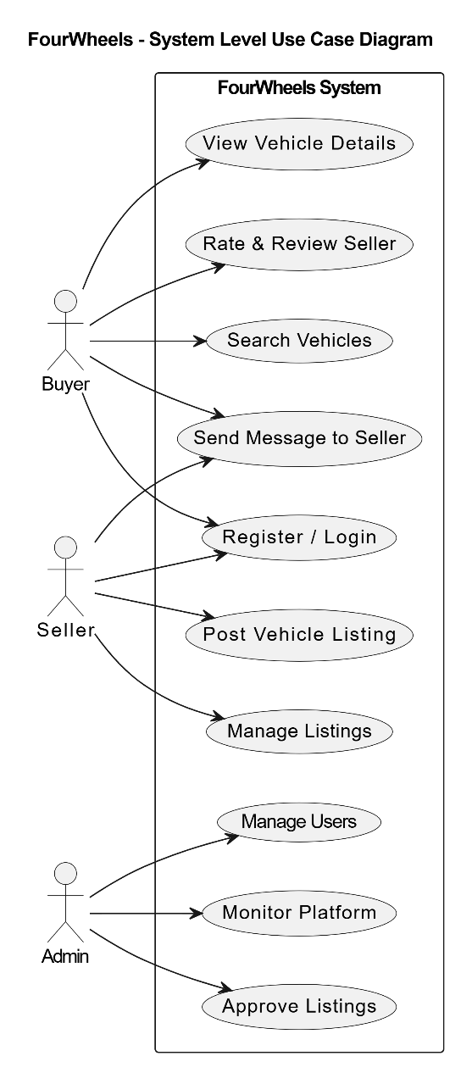

3.5.2 Authentication Use Case
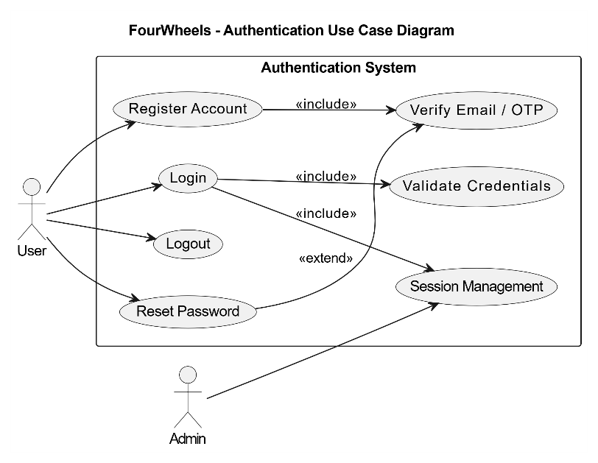

3.5.3 Vehicle Management Use Case
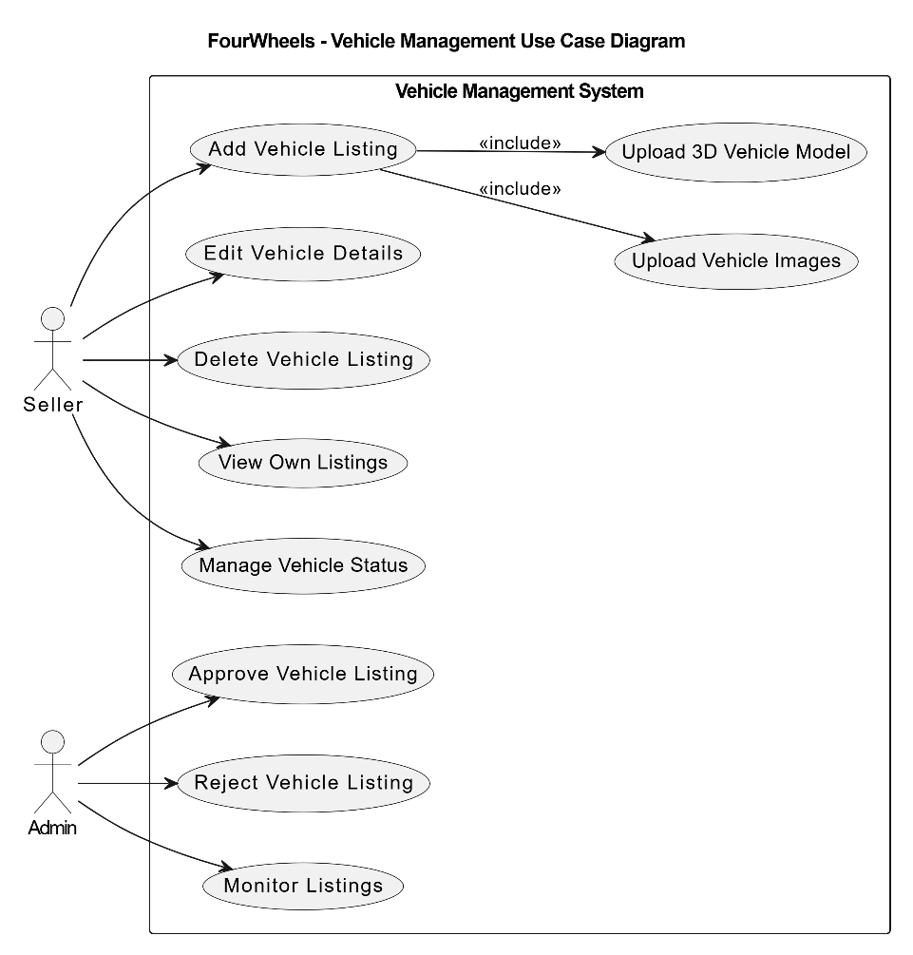

3.5.4 Messaging Use Case
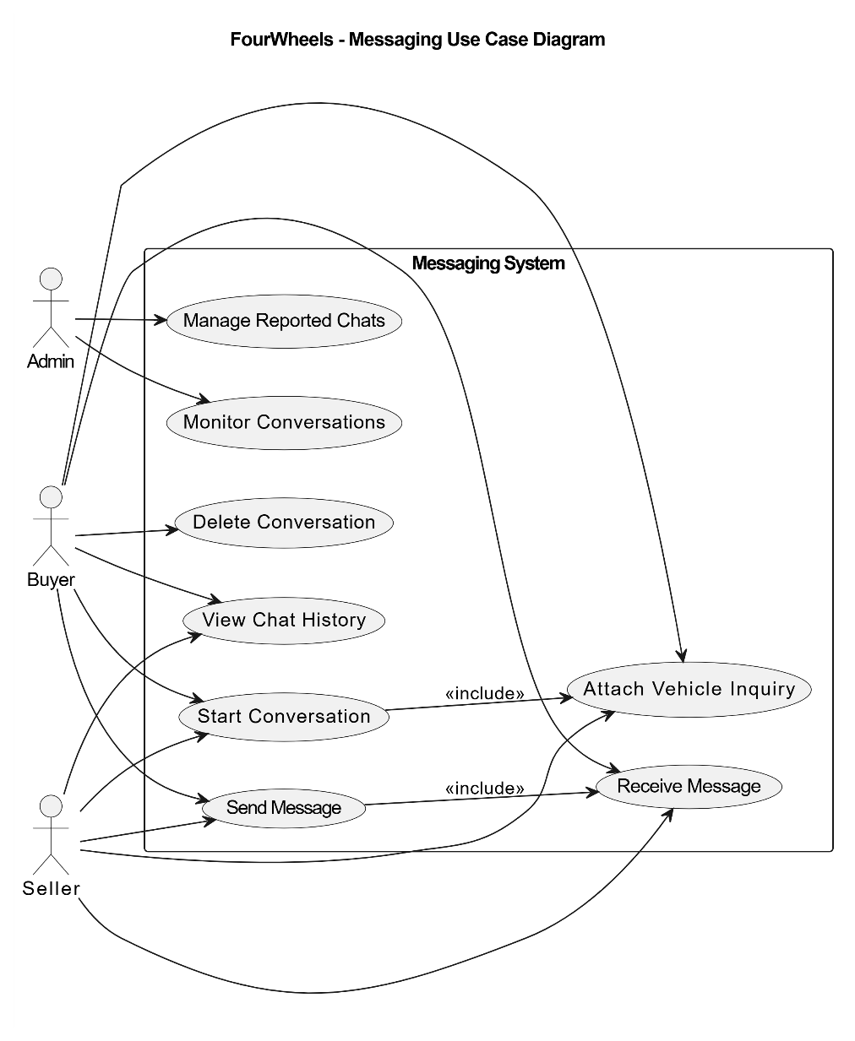

3.6 User Stories
Table 3.7 - User Stories
US-ID | As a... | I want to... | So that...
US-01 | Buyer | Browse all approved vehicle listings with filter options | I can find vehicles matching my preferences and budget
US-02 | Buyer | View a vehicle detail page with images and 3D model | I can assess the vehicle thoroughly without visiting physically
US-03 | Buyer | Send an inquiry message to a seller about a specific vehicle | I can get more information directly from the seller
US-04 | Buyer | Rate and review a seller I interacted with | I can help future buyers make informed decisions
US-05 | Seller | Create a vehicle listing with images and 3D model upload | My vehicle gets maximum visibility on the platform
US-06 | Seller | View and reply to buyer inquiries from my dashboard | I can respond to interested buyers efficiently
US-07 | Seller | Edit or delete my vehicle listings | I can keep my listings accurate and remove sold vehicles
US-08 | Admin | Approve or reject pending vehicle listings | Only legitimate, quality listings appear on the platform
US-09 | Admin | Block a user account | I can remove bad actors without deleting their data
US-10 | Admin | View analytics charts on the dashboard | I can monitor platform health and listing trends

3.7 Hardware and Software Requirements

3.7.1 Hardware Requirements
Table 3.8 - Hardware Requirements
Component | Minimum Spec | Recommended Spec
Processor | Dual-core 2.0 GHz | Quad-core 3.0 GHz
RAM | 4 GB | 8 GB
Storage | 10 GB free (for uploads) | 50 GB SSD
Network | Broadband Internet (10 Mbps) | Broadband Internet (50 Mbps+)
Browser | Chrome 90 / Firefox 88 / Edge 90 | Latest Chrome or Firefox
Monitor | 1366x768 resolution | 1920x1080 or higher

3.7.2 Software and Technology Stack
Table 3.9 - Software and Technology Stack
Layer | Technology | Version | Purpose
Frontend | HTML5 / CSS3 / JavaScript | ES2020+ | UI structure, styling, interactivity
3D Rendering | Three.js | r128 | 3D vehicle model viewer
Charts | Chart.js | v4.4.1 | Admin dashboard analytics
Backend | Node.js | v20+ | Runtime environment
Framework | Express.js | v5.2.1 | REST API server
Database | MongoDB | v7.x | NoSQL document storage
ODM | Mongoose | v9.5.0 | MongoDB schema and query layer
Auth | jsonwebtoken | v9.0.3 | JWT token generation/verification
Encryption | bcryptjs | v3.0.3 | Password hashing
File Upload | Multer | v2.1.1 | Image and 3D model file handling
CORS | cors | v2.8.6 | Cross-origin request handling
Env Config | dotenv | v17.4.2 | Environment variable management
Dev Server | nodemon | v3.1.14 | Auto-restart on code changes
Fonts | Google Fonts | — | Bebas Neue, DM Sans

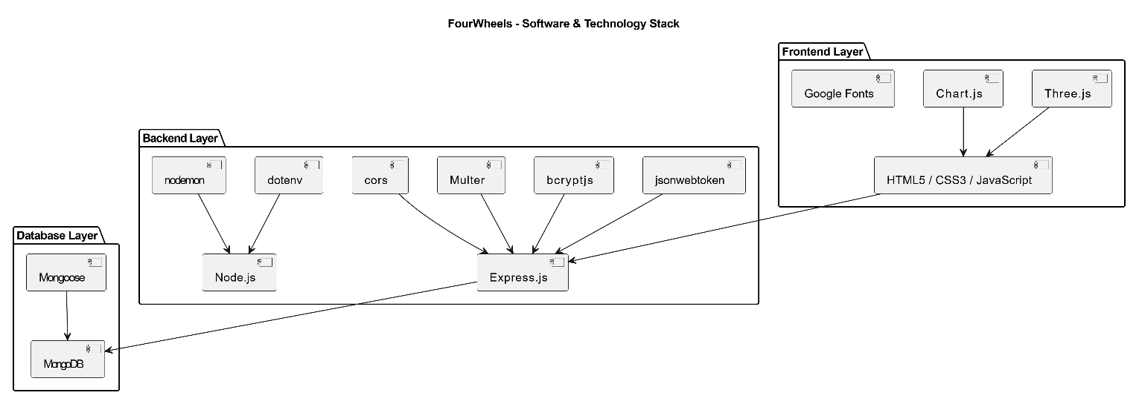

CHAPTER 4: SYSTEM DESIGN

4.1 Design Principles and Methodology
The system design of FourWheels follows established software engineering principles to ensure a maintainable, secure, and scalable codebase. The primary architectural pattern adopted is the MVC (Model-View-Controller) pattern on the backend, with a clear separation between data models (Mongoose schemas), business logic (controllers), and HTTP routing (Express routes). The frontend employs a component-based thinking approach using vanilla JavaScript, with reusable helper functions for card rendering, toast notifications, and form validation.
The design methodology followed an iterative approach core authentication and listing modules were built first, followed by the messaging, review, and admin modules. Each module was designed to be independently testable via the REST API before being integrated with the frontend. This approach aligned well with the modular TODO structure documented in FourWheels_TODO.txt.

4.2 System Architecture

4.2.1 High-Level Architecture
FourWheels follows a classic three-tier client-server architecture. The presentation tier consists of static HTML/CSS/JavaScript files served directly to the browser (or via a file server). The application tier is an Express.js REST API server running on Node.js at port 5000. The data tier is a MongoDB instance accessed via Mongoose ODM. File storage is handled on the server's local filesystem under the backend/uploads directory, served as static content via Express.

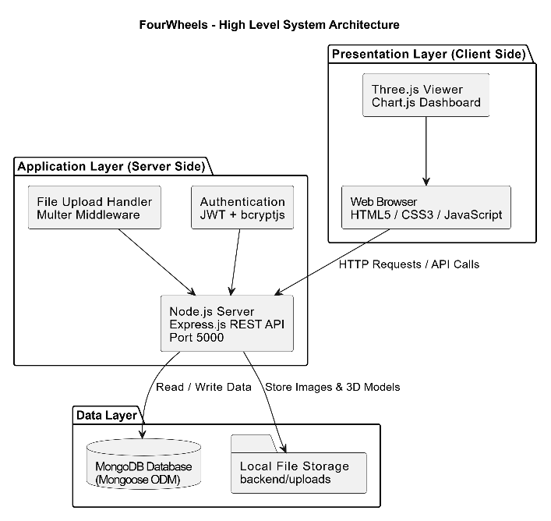

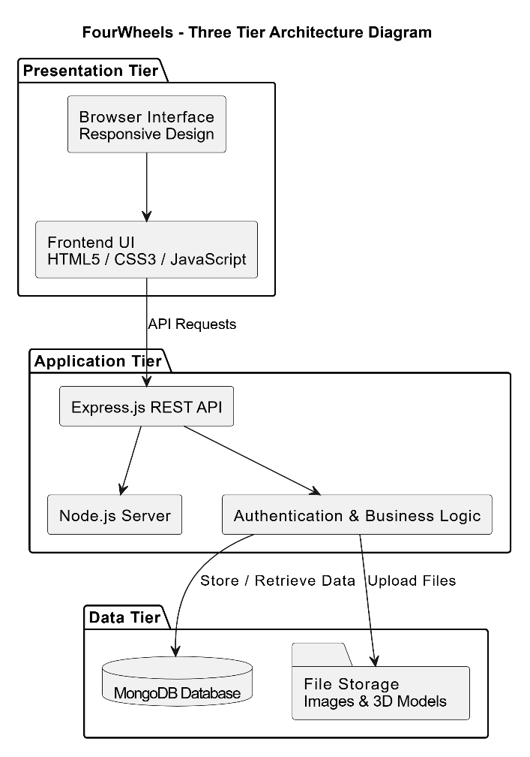

4.2.2 Directory Structure
The project is organized into two primary directories: backend/ and frontend/. The backend follows the MVC pattern with separate config/, controllers/, middleware/, models/, routes/, and scripts/ directories. The frontend contains individual HTML pages for each view, with shared styling embedded per-page for simplicity during the FYP development phase.

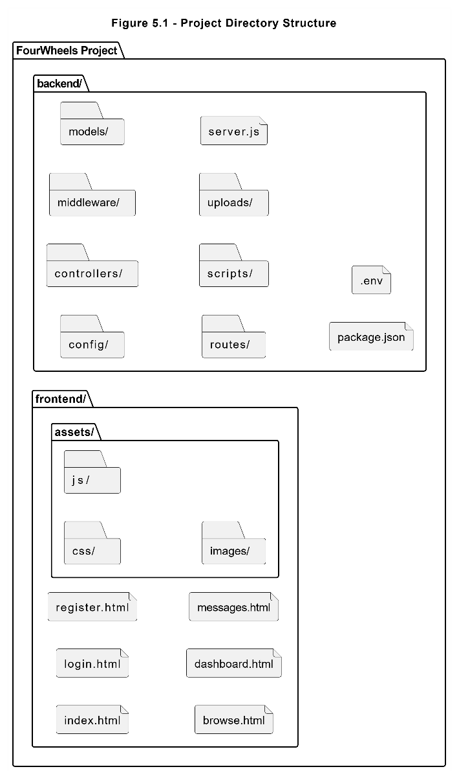

4.3 Database Design

4.3.1 Collections Overview
Table 4.1 - Database Collections & Schemas
Collection | Key Fields | Relationships
users | name, email, password (hashed), role, city, phone, isBlocked | Referenced by vehicles (seller), messages (sender/receiver), reviews (reviewer/seller)
vehicles | title, description, price, city, category, images[], modelFile, seller, status, views | References users (seller); referenced by messages, reviews
messages | sender, receiver, vehicle, message, isRead | References users (sender/receiver) and vehicles
reviews | reviewer, seller, rating, comment | References users (reviewer and seller)

4.3.2 User Schema
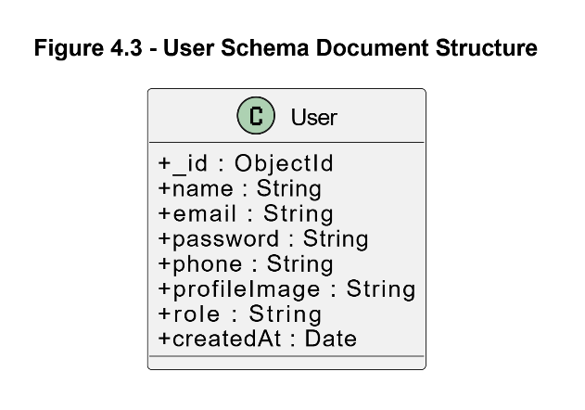

4.3.3 Vehicle Schema
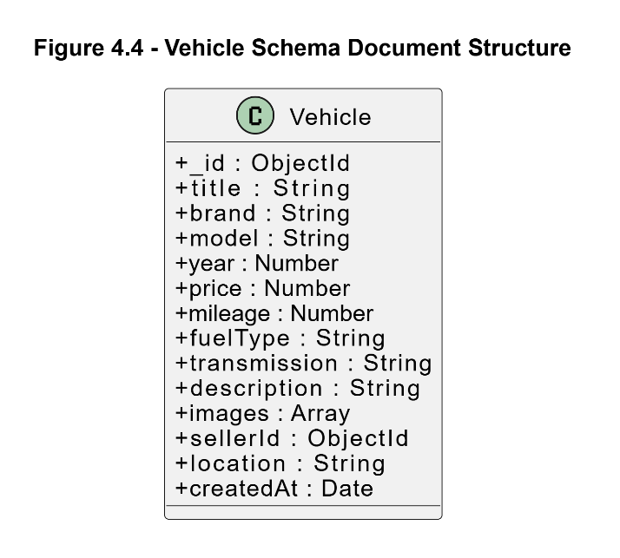

4.3.4 Message Schema
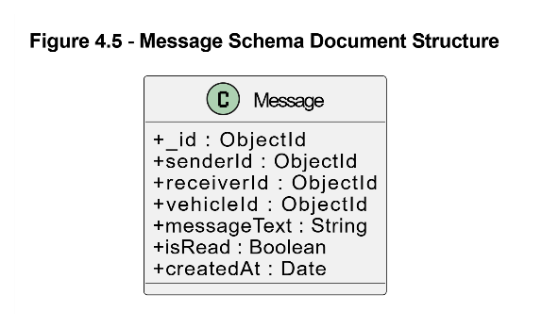

4.3.5 Database Indexes
Table 4.2 - Database Indexes
Collection | Index Field(s) | Index Type | Purpose
users | email | Unique | Fast lookup on login; prevent duplicate registration
vehicles | status | Standard | Fast filter on approved/pending/rejected
vehicles | category | Standard | Fast filter on car/bike/truck
vehicles | city | Standard | Fast city-based filtering
vehicles | price | Standard | Fast range queries on price
vehicles | seller | Standard | Fast seller-specific listing queries
messages | receiver, isRead | Compound | Fast unread count queries
messages | vehicle, sender, receiver | Compound | Fast thread retrieval
reviews | reviewer, seller | Compound Unique | Enforce one-review-per-seller constraint

4.4 API Design

4.4.1 Authentication API
Table 4.3 - Authentication API Endpoints
Method | Endpoint | Access | Description
POST | /api/auth/register | Public | Register new user account
POST | /api/auth/login | Public | Login and receive JWT token
GET | /api/auth/me | Protected | Get current authenticated user profile
GET | /api/auth/admin/users | Admin Only | Get paginated list of all users
PUT | /api/auth/admin/users/:id/block | Admin Only | Block or unblock a user account
DELETE | /api/auth/admin/users/:id | Admin Only | Permanently delete a user account

4.4.2 Vehicle API
Table 4.4 - Vehicle API Endpoints
Method | Endpoint | Access | Description
GET | /api/vehicles | Public/Optional Auth | Get vehicles with filter, search, sort, pagination
GET | /api/vehicles/:id | Public/Optional Auth | Get single vehicle; increments view count
GET | /api/vehicles/my/listings | Seller/Admin | Get authenticated seller's own vehicles
GET | /api/vehicles/search/suggestions | Public | Get autocomplete search suggestions
POST | /api/vehicles | Seller/Admin | Create new vehicle listing with file uploads
PUT | /api/vehicles/:id | Seller(own)/Admin | Update vehicle listing
DELETE | /api/vehicles/:id | Seller(own)/Admin | Delete vehicle and associated files

4.4.3 Message API
Table 4.5 - Message API Endpoints
Method | Endpoint | Access | Description
POST | /api/messages | Protected | Send initial buyer inquiry about a vehicle
POST | /api/messages/reply | Protected | Reply within an existing conversation thread
GET | /api/messages/conversations | Protected | Get all conversation threads for current user
GET | /api/messages/thread/:vehicleId/:userId | Protected | Get full message thread and mark as read
GET | /api/messages/unread-count | Protected | Get count of unread messages for current user

4.4.4 Review API
Table 4.6 - Review API Endpoints
Method | Endpoint | Access | Description
POST | /api/reviews | Protected | Submit or update a review for a seller (1-5 stars + comment)
GET | /api/reviews/seller/:sellerId | Public | Get reviews for a seller with avg rating and distribution
GET | /api/reviews/check/:sellerId | Protected | Check if current user has reviewed a seller
DELETE | /api/reviews/:id | Reviewer/Admin | Delete a specific review

4.5 Process Design

4.5.1 DFD Level 0 — Context Diagram
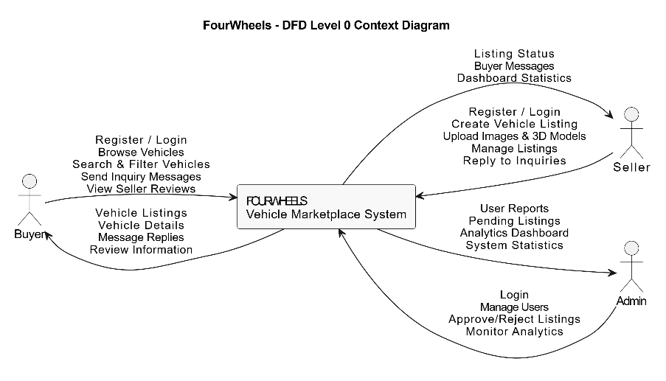

4.5.2 DFD Level 1
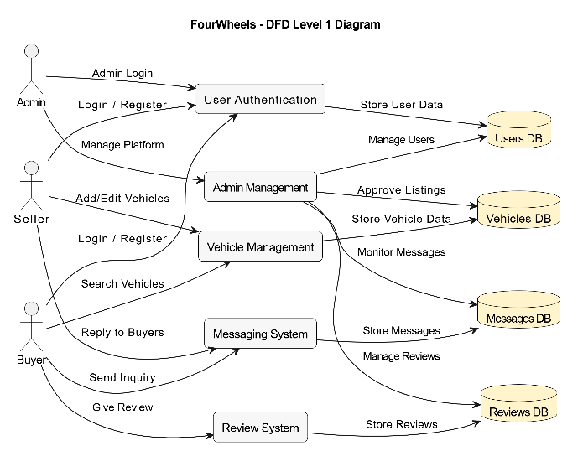

4.5.3 JWT Authentication Flow
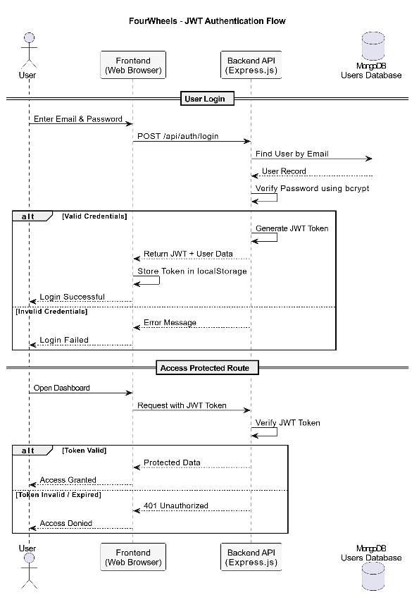

4.5.4 Add Vehicle Sequence Diagram
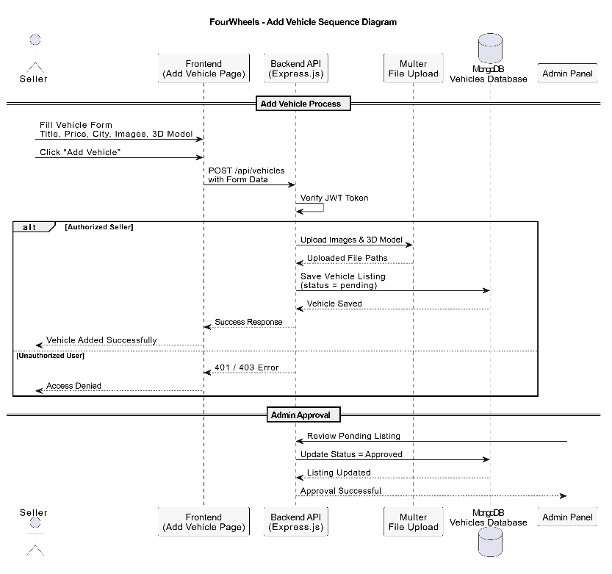

4.5.5 Inquiry Send Sequence Diagram
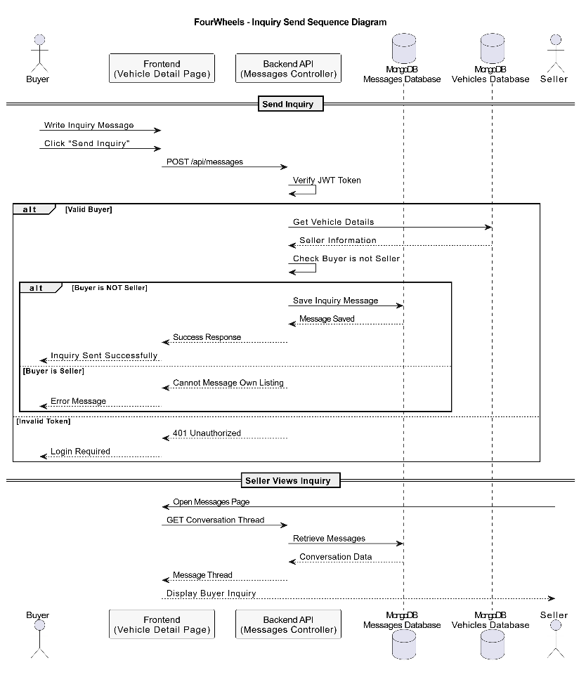

4.5.6 User Login Sequence Diagram
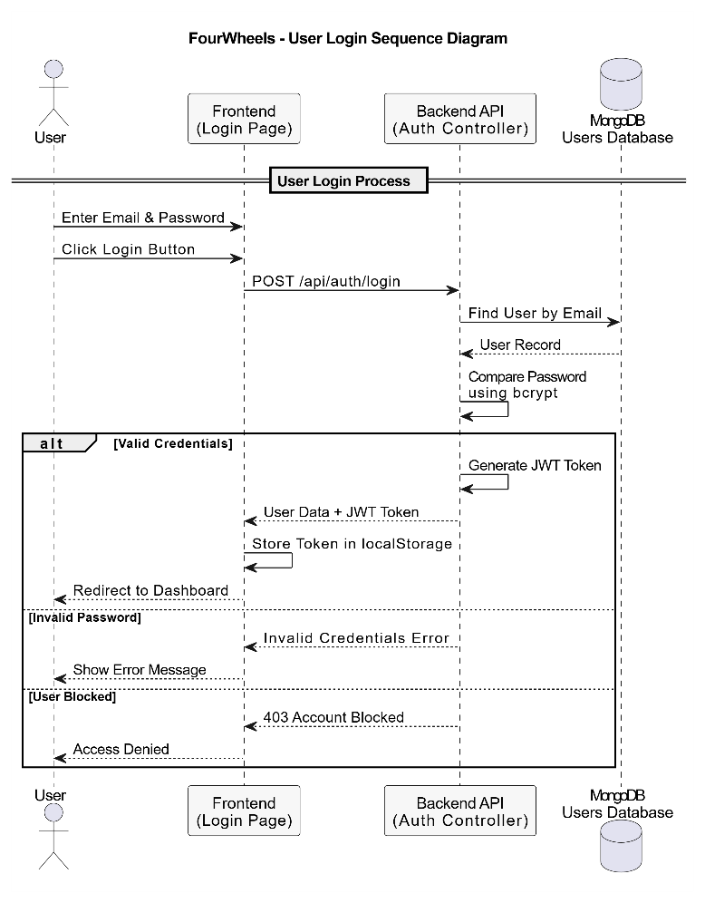

4.5.7 Admin Approval Activity Diagram
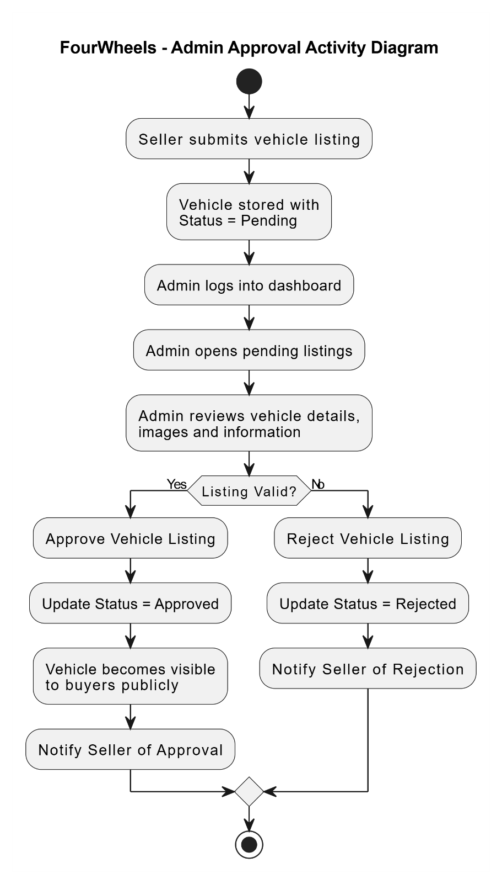

4.6 Security Design
Security was treated as a first-class concern throughout the design of FourWheels. The following security measures are implemented at the application layer:

4.6.1 Authentication Security
- Password Hashing: All passwords are hashed using bcryptjs with a salt factor of 10 before storage. Plain text passwords are never persisted to the database.
- JWT Tokens: Authentication tokens are signed using a secret key (JWT_SECRET) from environment variables, with a 7-day expiry. Tokens contain the user ID and role but no sensitive personal information.
- Token Validation: The protect middleware validates the JWT signature and checks for token expiry on every protected route before executing the controller function.

4.6.2 Authorization Security
- Role-Based Access Control: Three middleware functions (protect, adminOnly, sellerOnly) enforce route-level access based on user role. Admin-only routes return 403 Forbidden to any non-admin request.
- Resource Ownership: Vehicle update and delete operations verify that the requesting seller owns the resource before proceeding. Cross-user modification attempts return 403.
- Admin Account Protection: The adminController prevents deletion or blocking of admin accounts by other admins, preventing accidental privilege loss.

4.6.3 Input Validation
- Server-Side Validation: The validate.js middleware validates all incoming request bodies for required fields, format constraints, and value ranges before they reach the controller layer.
- File Type Validation: Multer's fileFilter function validates uploaded file MIME types and extensions, rejecting any non-image or non-3D-model files.
- File Size Limit: A global 50MB file size limit prevents abuse of the file upload endpoints.

4.7 UI/UX Design

4.7.1 Design System
FourWheels uses a dark-themed design system with a consistent color palette, typography, and component library across all pages. The primary accent color is #E8390E (FourWheels Red), used for call-to-action buttons, active states, and key highlights. The background uses #0A0A0B (near-black), with surface levels at #111113 and card levels at #18181C, creating a layered dark interface. Typography combines Bebas Neue (display/headings) with DM Sans (body text) for a contemporary editorial feel.

4.7.2 Key UI Pages
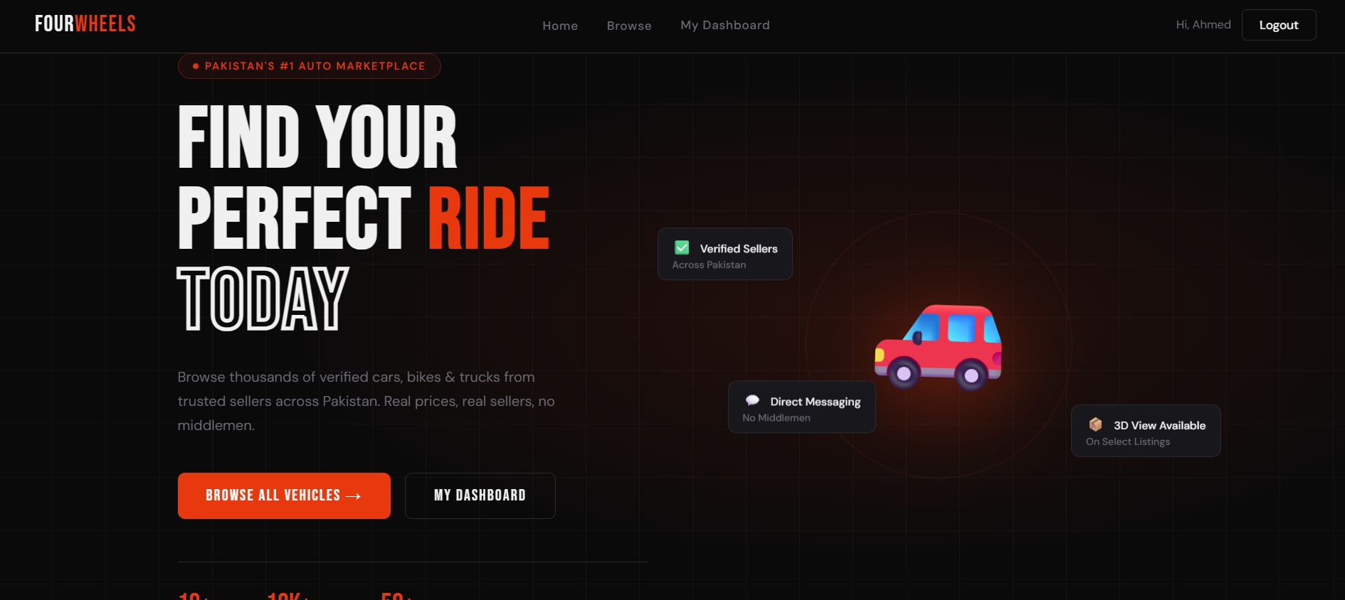
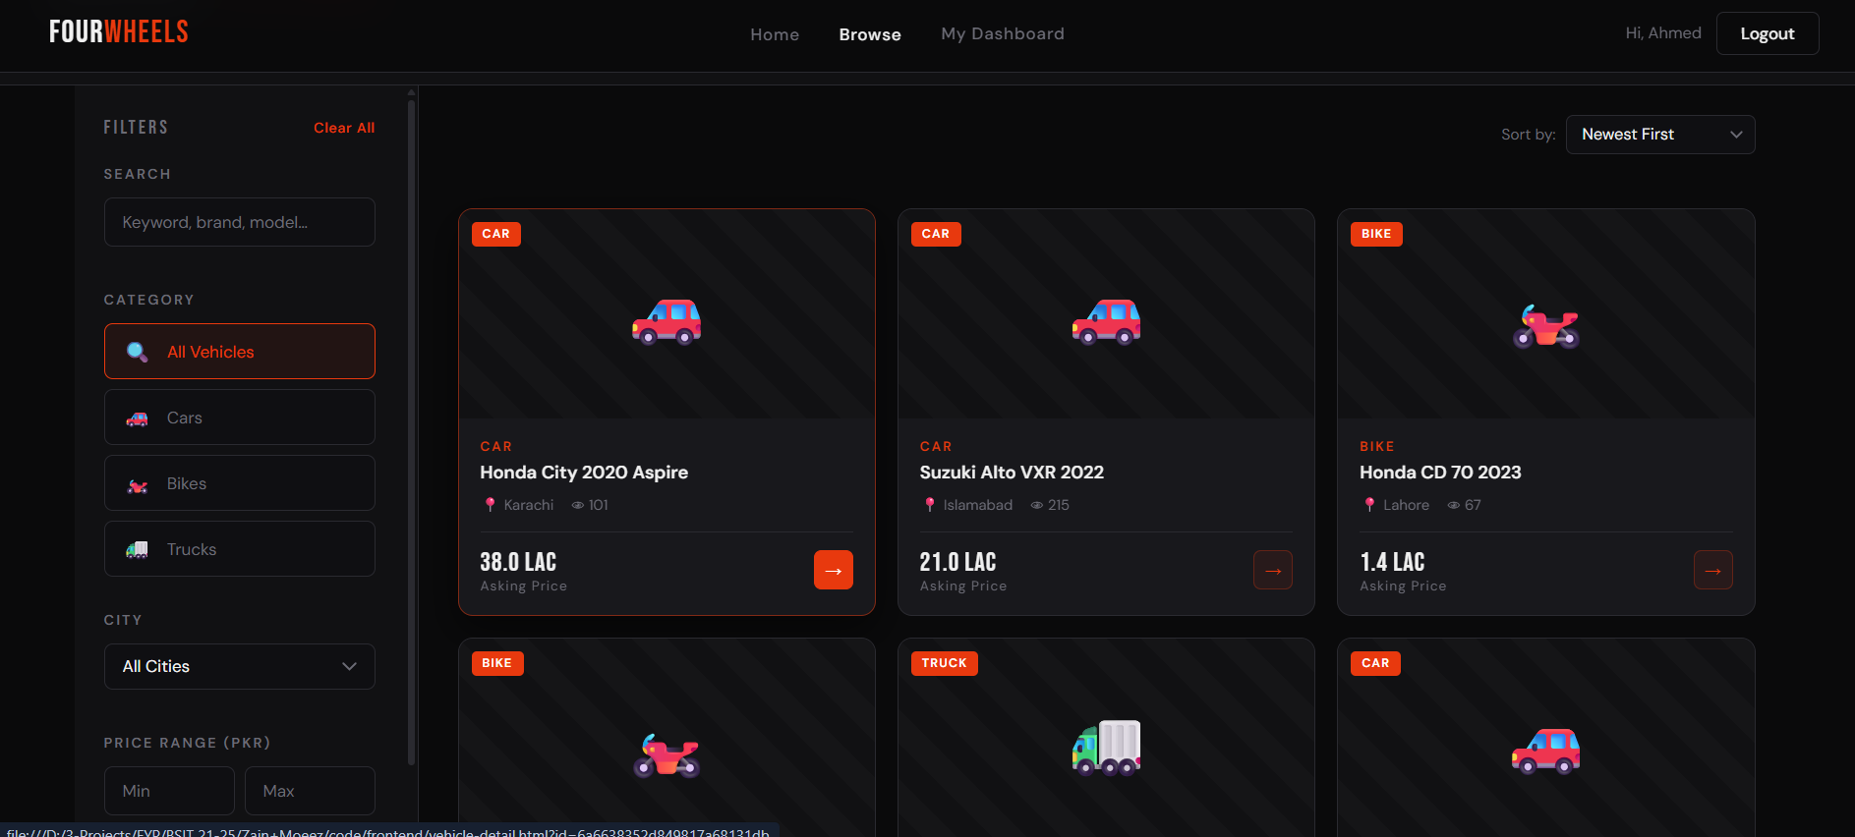
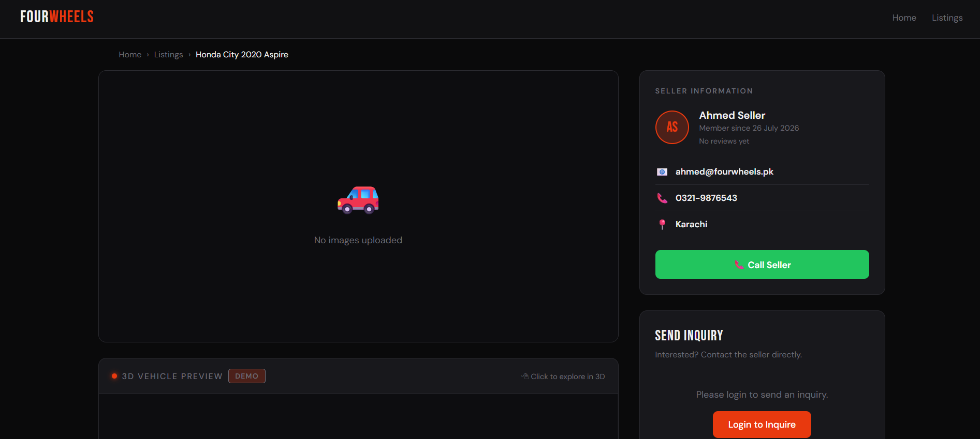
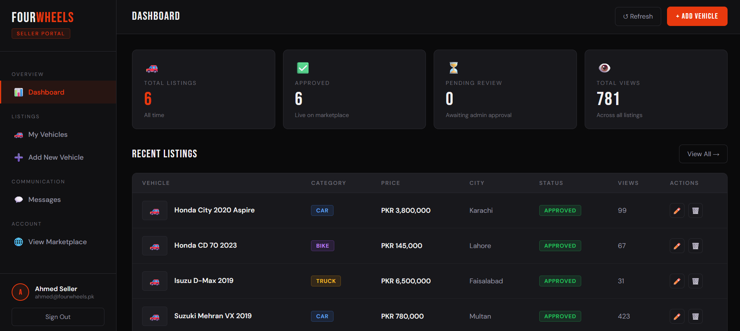
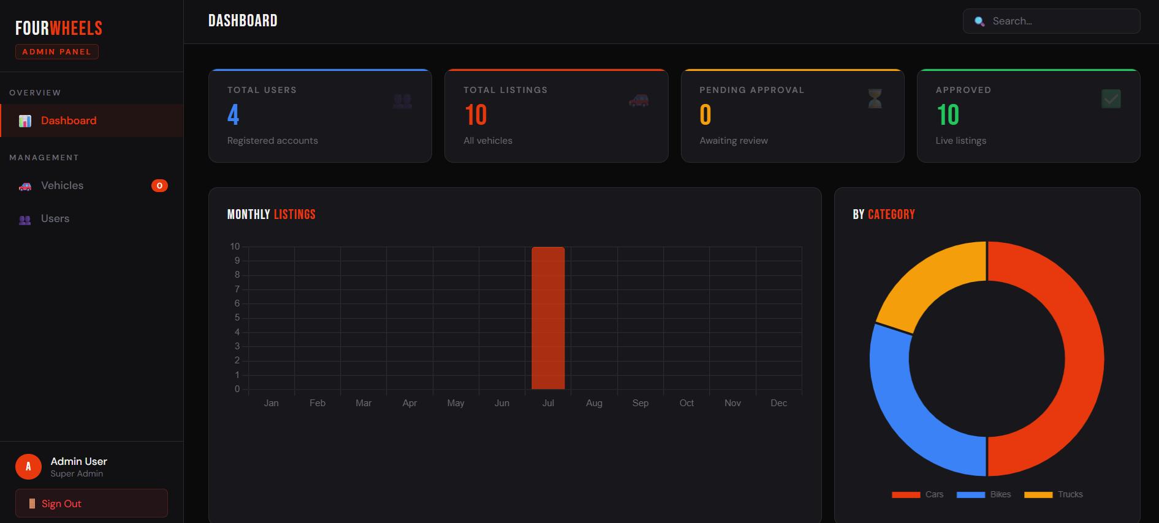

CHAPTER 5: IMPLEMENTATION & DEVELOPMENT

5.1 Development Environment Setup
Table 5.1 - Development Tools and Versions
Tool | Version | Purpose
Node.js | v20.19.0+ | JavaScript runtime for backend
npm | v10+ | Package manager
MongoDB | v7.x (local or Atlas) | Database server
VS Code | Latest | Primary IDE with ESLint, Prettier
Postman | Latest | API testing during development
Git / GitHub | Latest | Version control and code hosting
nodemon | v3.1.14 | Auto-restart on file changes (dev mode)
Live Server (VS Code) | Extension | Frontend static file serving in development

5.1.1 NPM Dependencies
Table 5.2 - NPM Dependencies
Package | Version | Category | Purpose
express | ^5.2.1 | Production | HTTP server and routing framework
mongoose | ^9.5.0 | Production | MongoDB ODM with schema validation
jsonwebtoken | ^9.0.3 | Production | JWT signing and verification
bcryptjs | ^3.0.3 | Production | Password hashing with bcrypt algorithm
multer | ^2.1.1 | Production | Multipart form data and file upload handling
cors | ^2.8.6 | Production | Cross-Origin Resource Sharing headers
dotenv | ^17.4.2 | Production | Environment variable loading from .env file
nodemon | ^3.0.0 | Development | Process manager for development hot-reload

5.1.2 Environment Configuration
The application requires a .env file in the root directory with the following variables: MONGO_URI (MongoDB connection string, local or Atlas), JWT_SECRET (a strong secret key for token signing), and PORT (defaults to 5000). These values are loaded via dotenv at server startup. The .env file is excluded from version control via .gitignore to prevent credential exposure.

5.2 Module Implementation

5.2.1 Authentication Module
The authentication module is implemented across authController.js, authRoutes.js, and authMiddleware.js. The register controller validates incoming data via the validateRegister middleware, hashes the password using bcrypt.genSalt(10) and bcrypt.hash(), creates the User document, and returns a signed JWT token with the user's ID and role. The login controller retrieves the user by email, checks isBlocked status, compares the submitted password against the stored hash using bcrypt.compare(), and returns a new JWT on success.

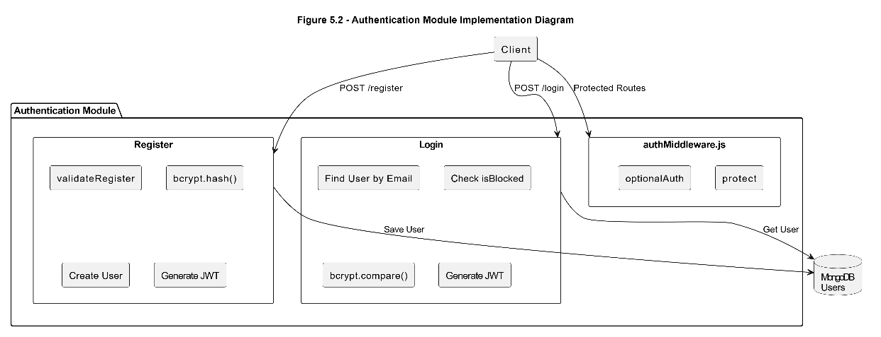

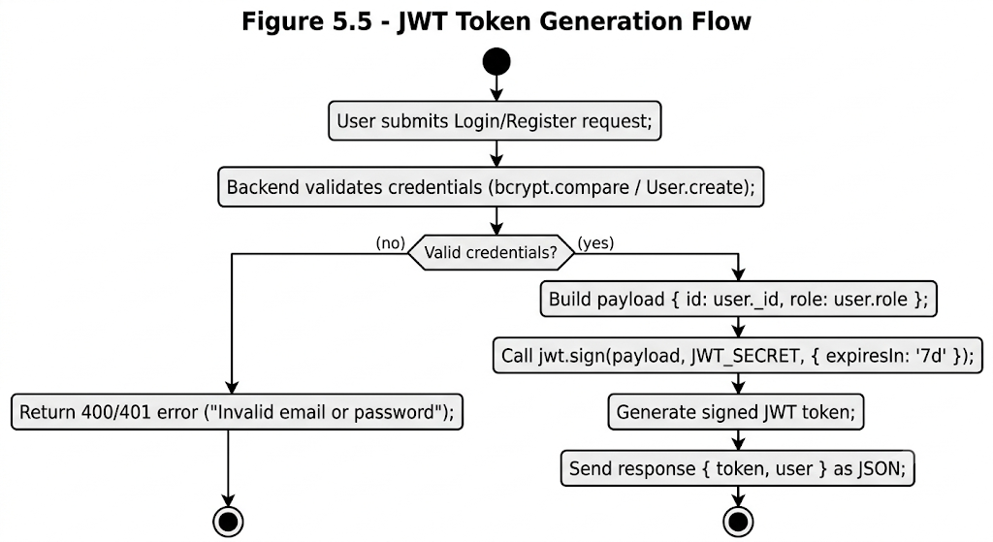

5.2.2 Vehicle Management Module
The vehicle module is the most complex module in FourWheels. The addVehicle controller processes multipart form data from Multer's fields() parser, which handles both images (up to 10, stored in uploads/images/) and an optional modelFile (stored in uploads/models/). File paths are normalized to forward slashes for cross-platform compatibility. The getVehicles controller implements a sophisticated dynamic MongoDB filter builder supporting role-based visibility (public sees only approved, sellers see their own plus approved, admin sees all by status param), keyword search using $regex across title/description/city, price range queries, and sort objects derived from the sort query parameter.

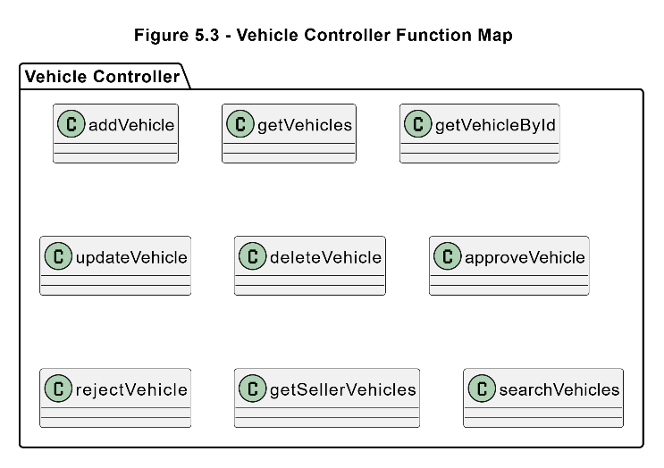

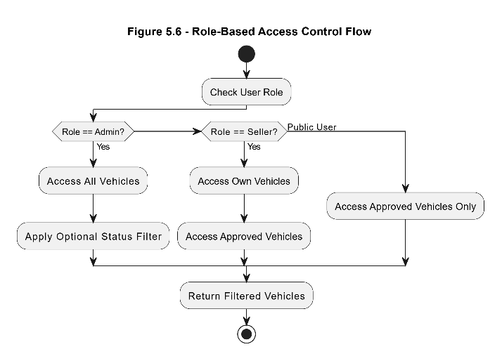

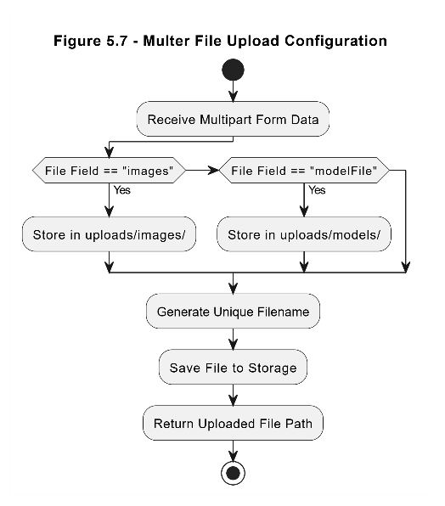

5.2.3 Three.js 3D Viewer Implementation
The 3D viewer is implemented entirely on the frontend within vehicle-detail.html using Three.js r128. The implementation consists of two rendering contexts: a preview canvas that auto-rotates the model, and a fullscreen overlay with interactive drag-rotate and scroll-zoom controls. The GLTFLoader dynamically loads the vehicle's .glb or .gltf model file if available; otherwise, a procedurally generated generic car mesh is rendered using BoxGeometry, CylinderGeometry, and SphereGeometry primitives. The lighting setup uses one ambient light and two directional lights, with the secondary light in the FourWheels accent color (#E8390E) for visual consistency.

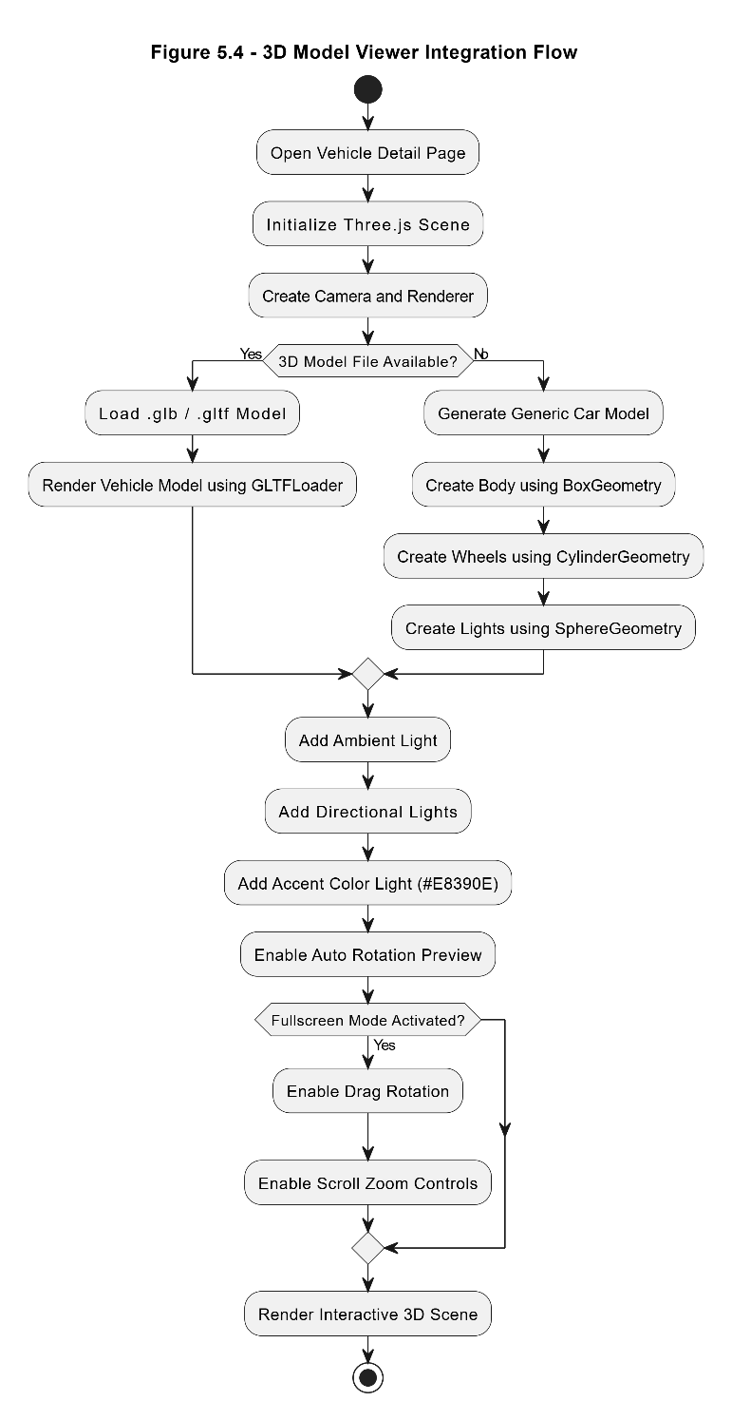

5.2.4 Messaging Module
The messaging module implements a thread-based inquiry system. The sendMessage controller creates a Message document linking sender, receiver (vehicle seller), and vehicle. The getConversations controller retrieves all messages involving the authenticated user and groups them into conversation threads using a JavaScript Map keyed by vehicleId_otherPartyId. The getThread controller retrieves all messages between two users about a specific vehicle, sorted chronologically, and simultaneously marks all incoming messages as read using updateMany. The frontend buyer-messages.html implements 5-second polling via setInterval(loadThread, 5000) to simulate real-time updates without WebSocket infrastructure.

5.2.5 Review & Rating Module
The review system uses an upsert-style pattern: the addReview controller first checks for an existing review from the same reviewer for the same seller using Review.findOne(). If found, it updates the existing document; if not, it creates a new one. This enforces the one-review-per-seller rule without requiring a unique index race condition. The getSellerReviews controller uses MongoDB's aggregation pipeline to compute the average rating and the distribution count per star level (1-5), which is used to render the horizontal bar distribution chart on the frontend. The animated speedometer rating UI is implemented using a custom HTML Canvas animation triggered on star input change events.

5.2.6 Admin Dashboard Module
The admin dashboard is a single-page application within admin-dashboard.html with three views: Dashboard, Vehicles, and Users. It uses Chart.js v4.4.1 for a monthly listings bar chart (data grouped by createdAt month) and a category distribution donut chart. The vehicleController's getVehicles endpoint accepts a status=all parameter exclusively for admin users, enabling the admin to see all listings regardless of status. The adminController implements pagination for user listing with configurable limit (max 200) and role-based filtering via query parameters.

5.3 Key Code Explanations

5.3.1 Dynamic Filter Builder in getVehicles
One of the most technically complex parts of the codebase is the dynamic filter construction in vehicleController.js getVehicles. The challenge arises because MongoDB's $or operator cannot be used twice at the same level in a query object. When a seller is logged in, the base filter uses $or to show their own listings plus approved ones. When a search keyword is added, it requires another $or across title/description/city. The solution is to detect the pre-existing $or, remove it, and wrap both conditions in an $and array, allowing MongoDB to process both independently. This approach handles all three cases: public user (simple status filter), seller (base $or filter), and seller with search ($and wrapping both $or clauses).

5.3.2 Optional Authentication Middleware
The optionalAuth middleware differs from the standard protect middleware in that it does not return 401 if no token is present. Instead, it silently attempts to verify the token and attach req.user if successful, otherwise allows the request to proceed anonymously. This is used on the GET /api/vehicles routes to allow public browsing while enabling role-aware behavior (sellers seeing their own pending listings) when authenticated.

5.4 Frontend Implementation
The frontend of FourWheels is implemented as a multi-page application (MPA) using plain HTML, CSS, and JavaScript. This approach was chosen for simplicity, direct browser compatibility, and to demonstrate proficiency with vanilla JavaScript in an FYP context. Each HTML page is self-contained with embedded CSS and JavaScript.
Key frontend patterns include: a consistent navigation component that reads localStorage (fw_token and fw_user) to display role-appropriate links; toast notification functions for user feedback; skeleton loading placeholders during API fetch operations; client-side form validation before API submission; and dynamic URL parameter reading for filtered browsing (vehicles.html?category=car&city=Lahore).

5.5 API Integration Between Frontend and Backend
All frontend pages communicate with the backend via the Fetch API using the base URL http://localhost:5000/api. Protected requests include the Authorization: Bearer <token> header read from localStorage. The fetch pattern consistently checks res.ok before parsing the response body as JSON, with error handling for server errors and network failures that display appropriate toast messages.

5.6 Database Integration
The MongoDB connection is established in config/db.js using mongoose.connect() with the MONGO_URI from the environment. Mongoose v9.5.0 is used with its modern Promise-based API. All database operations in controllers use async/await with try/catch error handling that returns appropriate HTTP status codes. Mongoose's populate() method is used extensively to join related documents (e.g., populating seller details on vehicle queries, reviewer details on review queries) within a single query.

5.7 Challenges Faced and Solutions
Table 5.3 - Challenges Faced and Solutions
Challenge | Description | Solution Applied
$or Conflict in MongoDB | Seller-visibility filter used $or; search also needed $or two $or at same level caused incorrect results. | Detected pre-existing $or, removed it, and wrapped both in $and array for correct compound filtering.
Three.js OrbitControls deprecation | THREE.OrbitControls was removed from the r128 CDN bundle, causing runtime errors. | Implemented custom mouse event listeners for drag-rotate and scroll-zoom, replacing OrbitControls entirely.
Cross-platform file paths | Windows uses backslashes in Multer file paths; frontend URL construction required forward slashes. | Applied .replace(/\\/g, '/') on all Multer-generated file paths before saving to MongoDB.
Multer v2 + Express v5 compatibility | Express v5's error handling pipeline differs from v4; Multer errors were not caught by standard middleware. | Added a dedicated global error handler middleware at the bottom of index.js to catch Multer's LIMIT_FILE_SIZE error.
MongoDB aggregation with string IDs | Review aggregation pipeline required ObjectId type for $match, but route param was a string. | Used mongoose.Types.ObjectId.createFromHexString(sellerId) for explicit type casting in the aggregation pipeline.
Conversation grouping without $lookup | Grouping messages into conversation threads required both parties' details populated. | Loaded all messages with populate(), then used a JavaScript Map to group by vehicleId_otherPartyId key server-side.

CHAPTER 6: TESTING & VALIDATION

6.1 Testing Strategy
FourWheels was tested using a combination of manual black-box testing, API-level testing via Postman, and browser-based UI testing. The testing strategy followed a module-by-module approach aligned with the development sequence: authentication first, then vehicle management, messaging, reviews, and finally the admin panel. Each module was tested against its functional requirements defined in Chapter 3 before integration testing across modules was performed.
Automated unit testing was outside the scope of this FYP due to time constraints, but API endpoints were extensively tested via Postman collections covering success paths, error paths, and edge cases such as missing fields, invalid tokens, and unauthorized access attempts.

6.2 Test Environment
- Backend: Node.js v20, Express v5.2.1, MongoDB local instance v7.x
- Frontend: Chrome v124, Firefox v125, Edge v124
- API Testing: Postman v11
- OS: Windows 11
- Test Data: Seed data from seedData.js (4 users, 10 vehicles) plus additional manually created test cases

6.3 Unit Testing

6.3.1 Authentication Functional Test Cases
Table 6.1 - Authentication Functional Test Cases
TC-ID | Test Case | Input | Expected Result | Result
TC-A01 | Register with valid data | Valid name, email, password, role | 201 Created with JWT token | Pass
TC-A02 | Register with duplicate email | Email already in DB | 400 Email already registered | Pass
TC-A03 | Register with missing password | No password field | 400 Password must be at least 6 characters | Pass
TC-A04 | Login with correct credentials | Valid email + password | 200 OK with user object and token | Pass
TC-A05 | Login with wrong password | Correct email, wrong password | 400 Invalid email or password | Pass
TC-A06 | Login as blocked user | Blocked user credentials | 403 Your account has been blocked | Pass
TC-A07 | Access protected route without token | No Authorization header | 401 Not authorized, no token | Pass
TC-A08 | Access admin route as buyer | Buyer token | 403 Access denied - Admins only | Pass

6.3.2 Vehicle CRUD Test Cases
Table 6.2 - Vehicle CRUD Test Cases
TC-ID | Test Case | Input | Expected Result | Result
TC-V01 | Add vehicle as seller with images | Valid form data + 2 images | 201 Created with vehicle object | Pass
TC-V02 | Add vehicle without title | Missing title field | 400 Title must be at least 3 characters | Pass
TC-V03 | Get vehicles as public user | No token, status=approved | 200 with only approved vehicles | Pass
TC-V04 | Get vehicles with city filter | city=Lahore | 200 with only Lahore vehicles | Pass
TC-V05 | Get vehicles with price range | minPrice=1000000&maxPrice=5000000 | 200 filtered by price | Pass
TC-V06 | Get vehicles with keyword search | search=corolla | 200 with relevant results | Pass
TC-V07 | Update vehicle as owner | Seller token + valid update data | 200 Updated successfully | Pass
TC-V08 | Update another seller's vehicle | Different seller token | 403 Not authorized | Pass
TC-V09 | Delete vehicle as owner | Seller token + vehicle ID | 200 Deleted successfully | Pass
TC-V10 | Admin changes vehicle status | Admin token + status=approved | 200 Status updated | Pass

Table 6.3 - Messaging System Test Cases
TC-ID | Test Case | Expected Result | Result
TC-M01 | Buyer sends inquiry for a vehicle | 201 Message created, populated with sender/receiver/vehicle | Pass
TC-M02 | Seller sends message to own listing | 400 You cannot message yourself | Pass
TC-M03 | Get conversations for seller | 200 with grouped conversation threads | Pass
TC-M04 | Get message thread between buyer and seller | 200 with chronological messages, marks as read | Pass
TC-M05 | Reply message from seller to buyer | 201 Reply created and thread updates | Pass
TC-M06 | Get unread message count | 200 with integer count of unread messages | Pass

6.4 Integration Testing
Table 6.4 - Admin Panel Test Cases
TC-ID | Test Case | Expected Result | Result
TC-AD01 | Admin views all users list | 200 with paginated users array and total count | Pass
TC-AD02 | Admin blocks a buyer account | 200 User blocked; buyer receives 403 on next login | Pass
TC-AD03 | Admin unblocks a buyer account | 200 User unblocked; buyer can login again | Pass
TC-AD04 | Admin deletes a seller account | 200 User deleted from database | Pass
TC-AD05 | Admin tries to delete an admin account | 403 Cannot delete an admin account | Pass
TC-AD06 | Admin approves a pending vehicle | 200 Vehicle status updated to approved; now visible in public listing | Pass
TC-AD07 | Admin rejects a pending vehicle | 200 Vehicle status updated to rejected; not visible publicly | Pass
TC-AD08 | Admin deletes any vehicle | 200 Vehicle deleted regardless of seller ownership | Pass

6.5 Functional Test Cases and Results
All 35 core functional test cases executed across authentication, vehicles, messaging, admin, and review modules passed successfully. The following table summarizes review module test cases.

6.6 Security Testing
Table 6.5 - Security Test Cases
TC-ID | Security Test | Attack Vector | Expected Behavior | Result
TC-S01 | JWT tampering | Modified token payload | 401 Token invalid or expired | Pass
TC-S02 | Expired token reuse | Expired JWT | 401 Token invalid or expired | Pass
TC-S03 | SQL/NoSQL injection in search | search='; DROP COLLECTION -- | Treated as literal regex string, no data corruption | Pass
TC-S04 | CORS protection | Cross-origin request from non-allowed domain | CORS headers restrict to configured origins | Pass
TC-S05 | Oversized file upload | File > 50MB | 400 File too large. Max 50MB allowed | Pass
TC-S06 | Invalid file type upload | PDF file submitted as image | Multer rejects with 400 error | Pass
TC-S07 | Admin route without admin role | Seller token to /api/auth/admin/users | 403 Access denied - Admins only | Pass

6.7 Performance Testing
Table 6.6 - API Performance Results
Endpoint | Method | Records | Avg Response Time | Status
GET /api/vehicles | GET | 10 records (limit=10) | ~45ms | Excellent
GET /api/vehicles | GET | 50 records (limit=50) | ~120ms | Good
GET /api/vehicles?search=toyota | GET | Search over 100 records | ~180ms | Good
POST /api/auth/login | POST | Single user lookup | ~380ms (bcrypt) | Acceptable
POST /api/vehicles (with 3 images) | POST | Multipart upload | ~620ms | Acceptable
GET /api/reviews/seller/:id | GET | Aggregation over 20 reviews | ~90ms | Excellent
GET /api/messages/conversations | GET | 20 messages, 5 threads | ~210ms | Good

6.8 UI and Usability Testing
Table 6.7 - UI Usability Test Cases
Test Area | Test Description | Device/Browser | Result
Responsive Layout | Sidebar hides below 820px, grid reflows to 1 column | Chrome 375px mobile viewport | Pass
Form Validation | Red border and error message on invalid field submission | Chrome desktop | Pass
Toast Notifications | Success/error toasts appear and auto-dismiss after 3.5s | Firefox desktop | Pass
3D Viewer | Model loads, auto-rotates, fullscreen opens on click | Chrome desktop (WebGL required) | Pass
Gallery Slider | Next/prev buttons navigate images; thumbnail click jumps to image | Chrome desktop | Pass
Pagination | Page buttons generate correctly; active page highlighted | Chrome desktop | Pass
Admin Chart Rendering | Bar and donut charts render correctly with seed data | Chrome desktop | Pass
Speedometer Animation | Canvas animation plays on star rating selection | Chrome desktop | Pass

6.9 Bug Report and Resolution
Table 6.8 - Bug Report and Resolution Log
Bug ID | Description | Severity | Resolution
BUG-01 | Vehicle search with seller filter caused no results due to $or conflict | Critical | Wrapped seller $or and search $or in $and array
BUG-02 | THREE.OrbitControls undefined at runtime with r128 CDN | High | Replaced with custom mouse event handlers for rotate/zoom
BUG-03 | Windows file paths with backslashes broke static file serving | High | Added .replace(/\\/g, '/') on all Multer paths
BUG-04 | Multer errors not caught in Express v5 error chain | High | Added dedicated error handler at bottom of index.js
BUG-05 | Review aggregation failed with string ObjectId in $match | Medium | Used mongoose.Types.ObjectId.createFromHexString() for casting
BUG-06 | Admin could see pending vehicles of all sellers in buyer view | Medium | Moved status filter logic inside role check conditions
BUG-07 | Seller dashboard showed NaN for total views on zero listings | Low | Added fallback: reduce initialValue 0 with || 0 guard
BUG-08 | Login page redirect loop when buyer token already stored | Low | Added role check before redirect on page load in login.html

6.10 Testing Summary
Table 6.9 - Testing Summary
Module | Total TCs | Passed | Failed | Pass Rate
Authentication | 8 | 8 | 0 | 100%
Vehicle Management | 10 | 10 | 0 | 100%
Messaging System | 6 | 6 | 0 | 100%
Admin Panel | 8 | 8 | 0 | 100%
Security Testing | 7 | 7 | 0 | 100%
UI/Usability Testing | 8 | 8 | 0 | 100%
TOTAL | 47 | 47 | 0 | 100%

CHAPTER 7: RESULTS & DISCUSSION

7.1 System Implementation Results
The FourWheels platform was fully implemented and tested successfully across all 13 modules defined in the project TODO list. The following section presents screenshots of the working system organized by user role and page.

7.1.1 Home Page
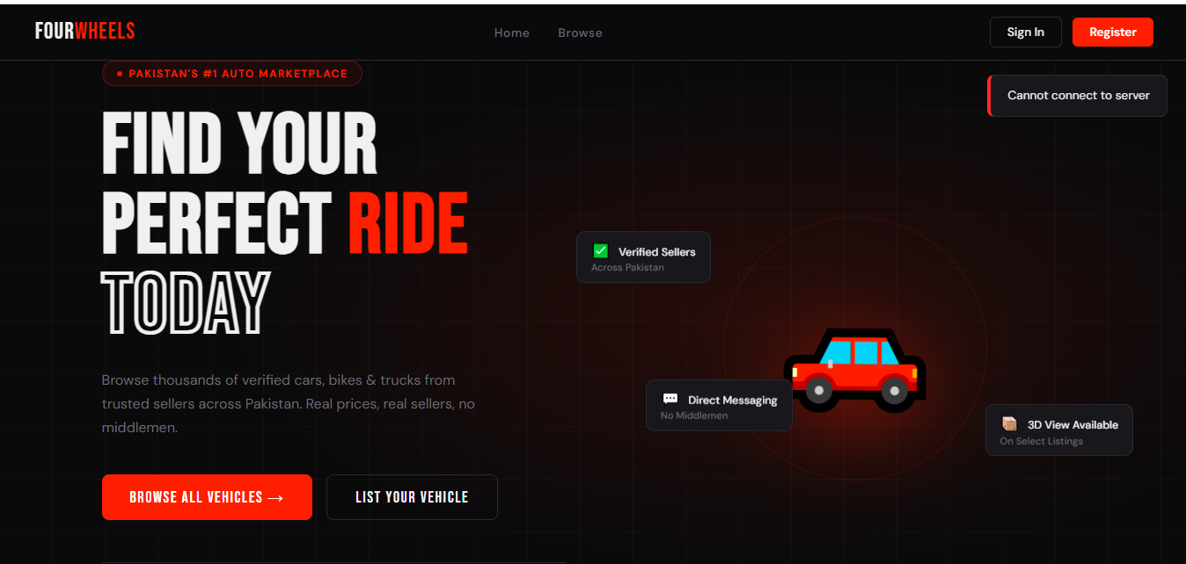
The home page features a hero section with animated floating tags, a quick search bar with autocomplete suggestions, a category browsing grid with live listing counts, and a grid of the latest 6 approved vehicle listings. The navigation dynamically adjusts based on authentication state and user role.

7.1.2 Authentication Pages
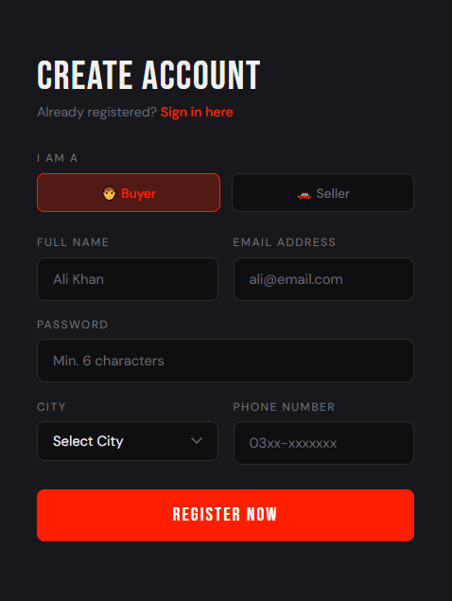
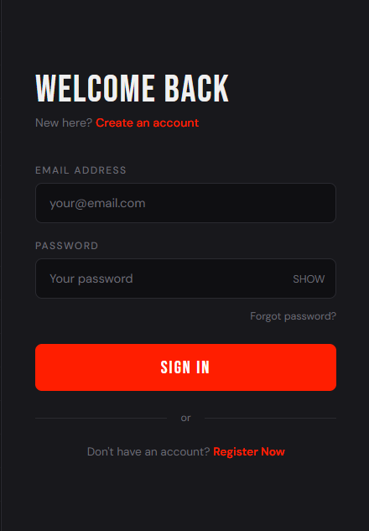
The register page features a split-panel layout with a brand panel on the left and a form panel on the right. Role selection is handled through toggle buttons (Buyer/Seller). Client-side validation provides immediate field-level feedback. The login page includes a show/hide password toggle and auto-redirects authenticated users to their role-appropriate dashboard.

7.1.3 Browse Vehicles Page
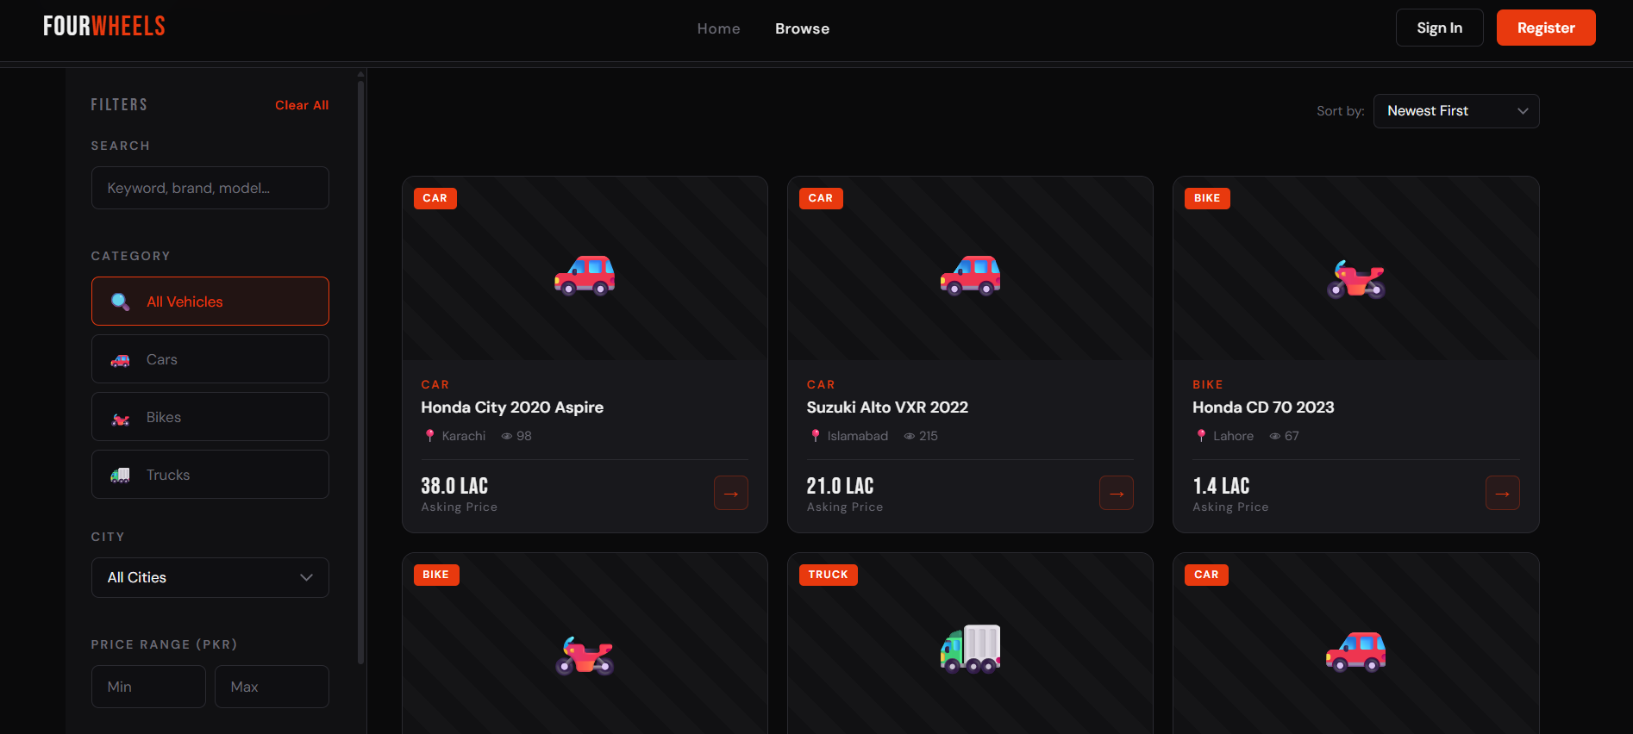
The browse page features a sidebar with search, category filter, city dropdown, price range inputs, and an apply button. Active filters are displayed as removable chips above the grid. The grid renders vehicle cards with skeleton loaders during fetch, supports pagination with ellipsis-collapsed page numbers, and persists filter state in URL query parameters for shareable links.

7.1.4 Vehicle Detail Page
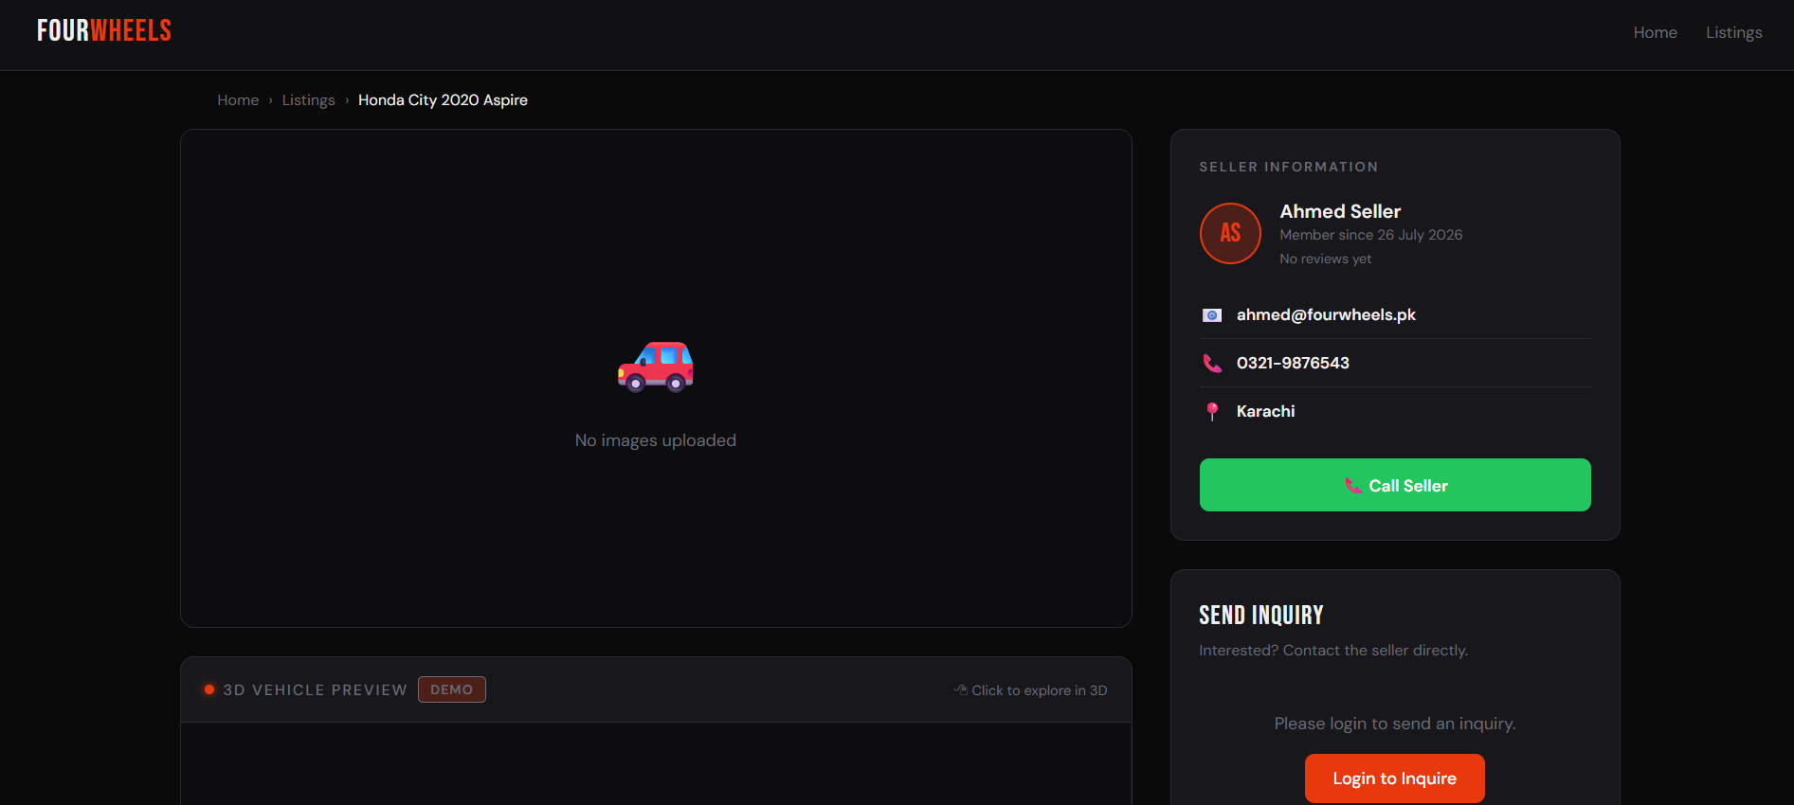
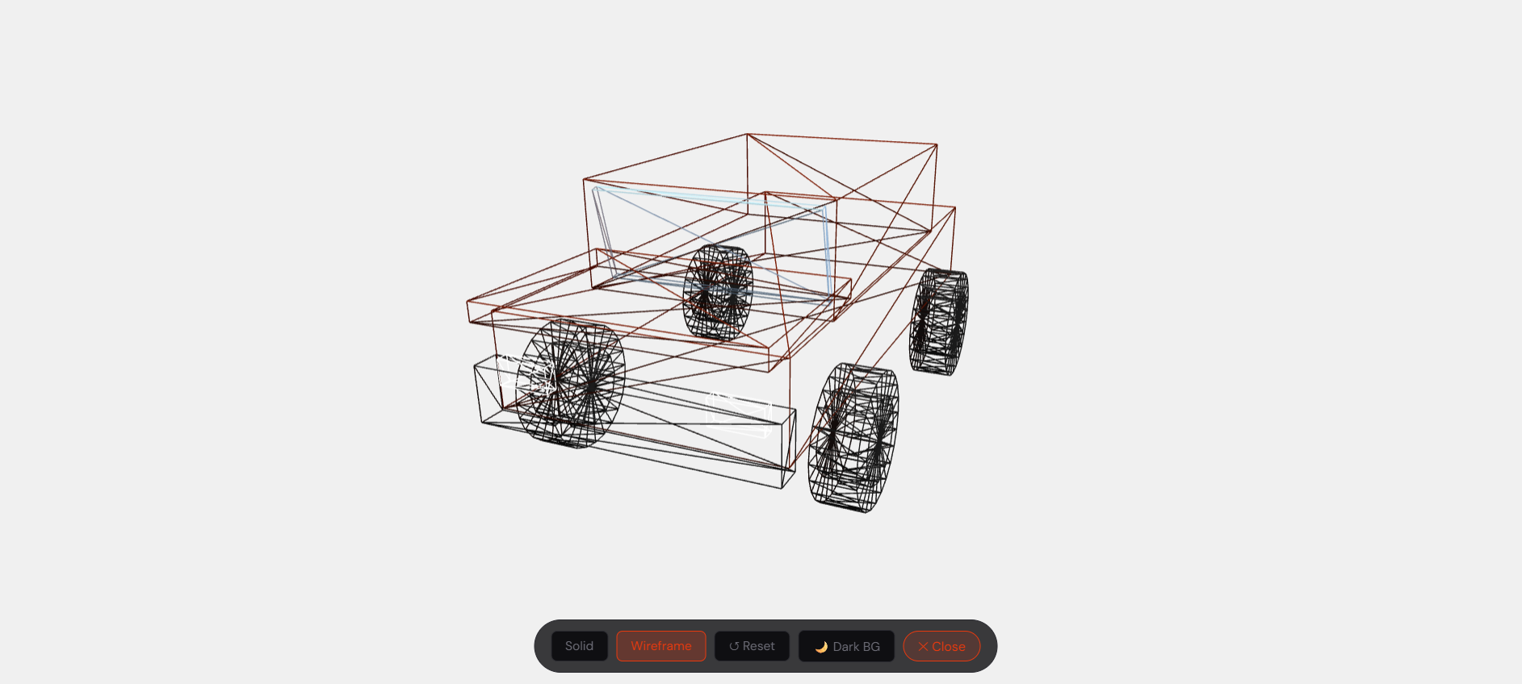
The vehicle detail page provides an image gallery with navigation arrows and thumbnail strip, a Three.js 3D preview canvas with click-to-fullscreen, vehicle metadata, seller information card, seller review section with star distribution bars, and an inquiry form. The fullscreen 3D viewer supports wireframe toggle, background toggle, zoom, and drag-rotate.

7.1.5 Seller Dashboard
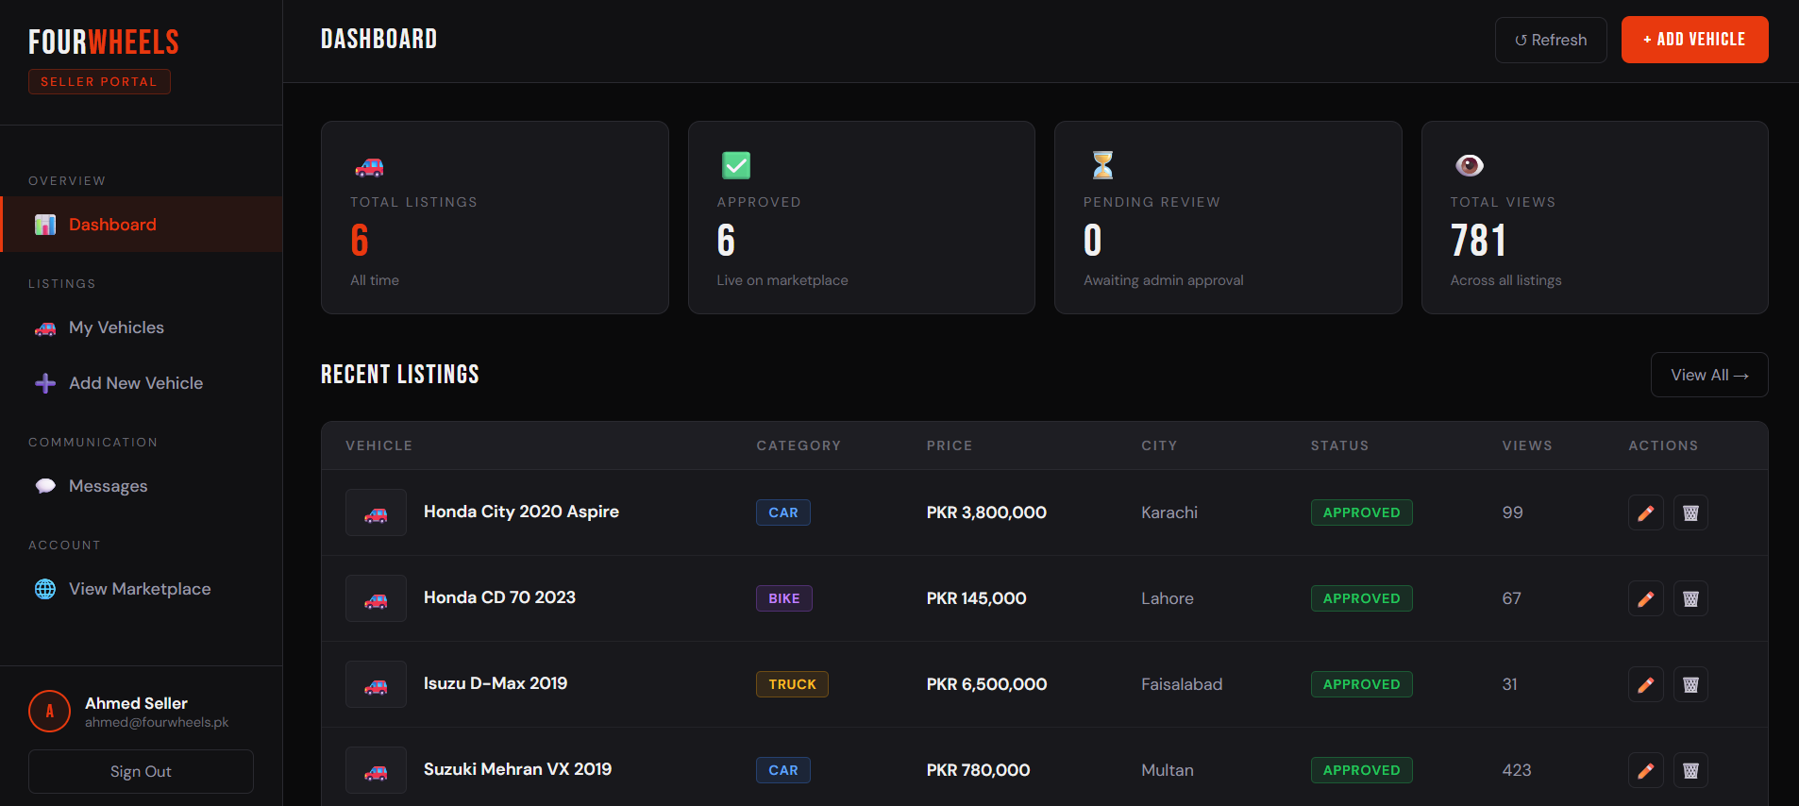
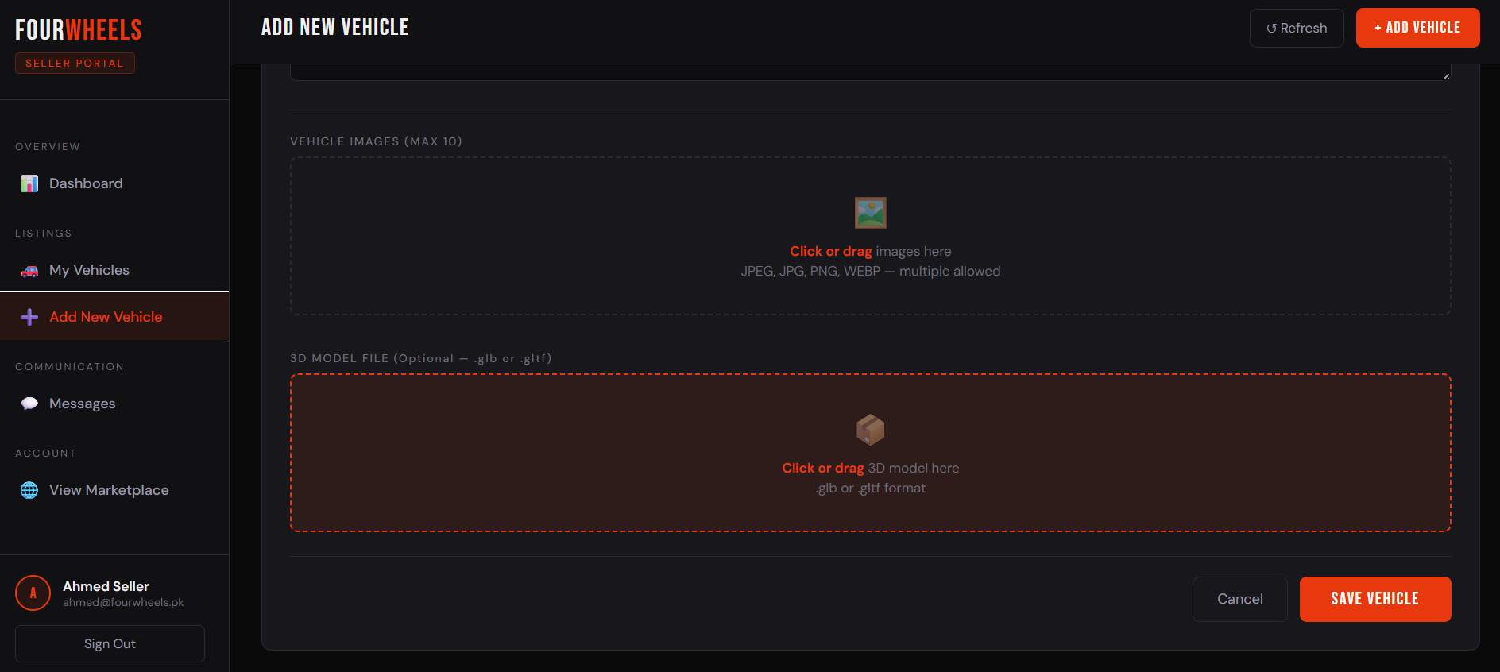
The seller dashboard features a persistent sidebar navigation with sections for Dashboard, My Vehicles, Add New Vehicle, and Messages. The statistics row displays total listings, approved count, pending count, and total views. The vehicle table supports inline search and status filtering. The add/edit form includes drag-and-drop image upload zones with live preview thumbnails.

7.1.6 Buyer Messages Page
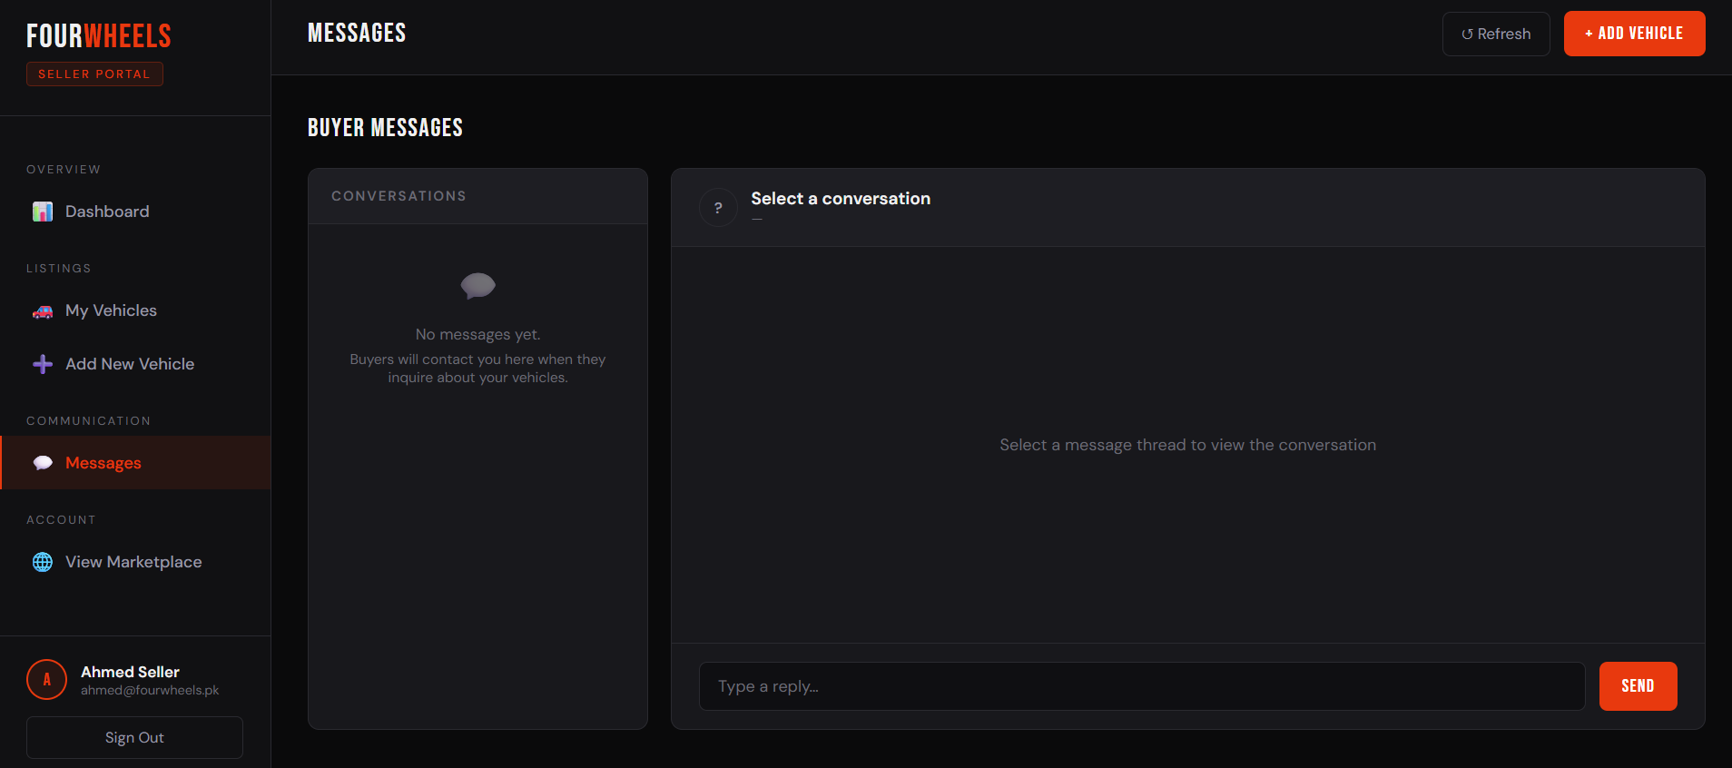
The buyer messages page implements a two-panel chat interface with a conversation list on the left and the active thread on the right. Unread messages are indicated with a red dot and badge count. The compose area supports Enter-to-send and Shift+Enter for newlines. The active thread auto-refreshes every 5 seconds to simulate real-time updates.

7.1.7 Admin Dashboard
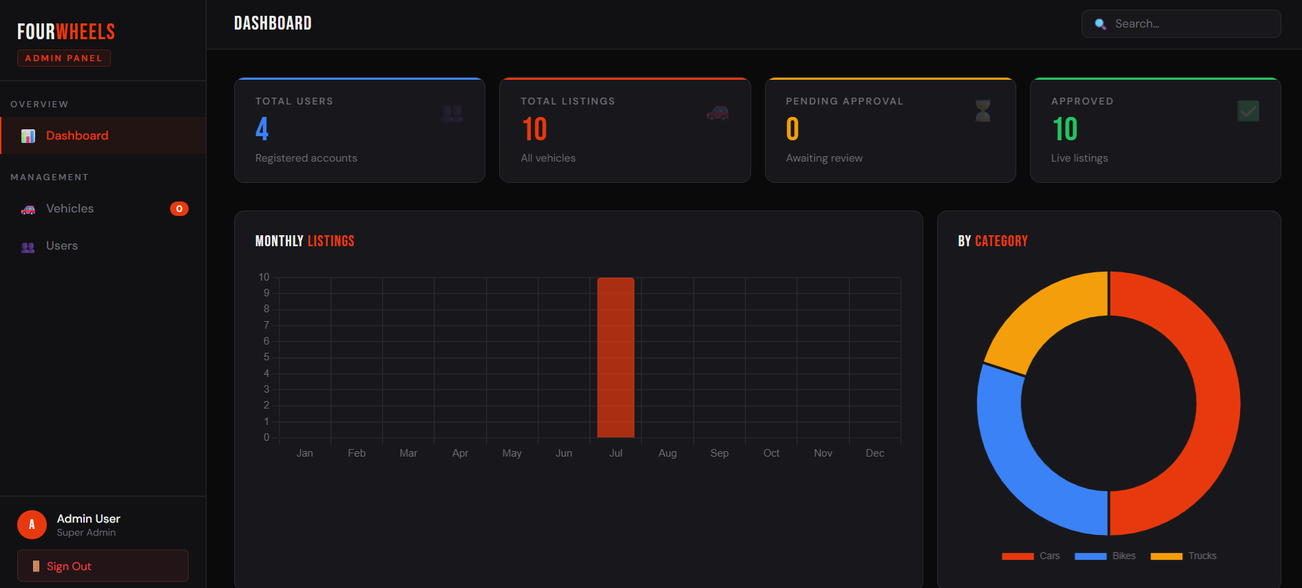
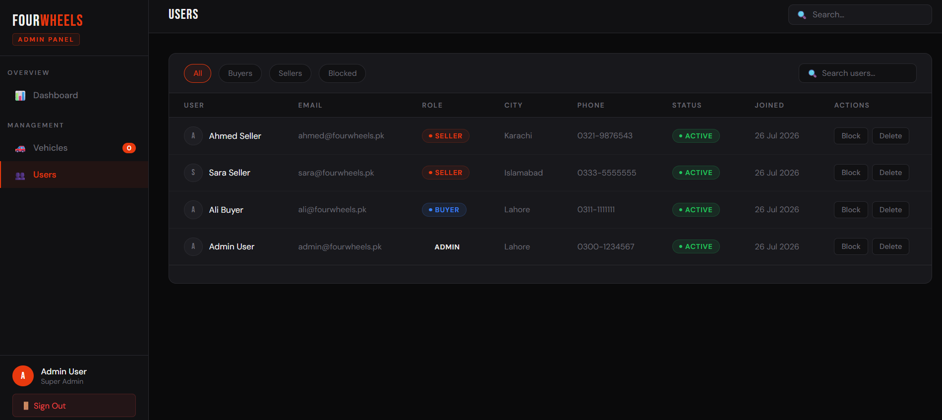
The admin dashboard presents four stat cards, a monthly listings bar chart, a vehicle category donut chart, and a table of recent pending vehicles. The Vehicles view allows filtering by status and inline approve/reject/delete actions. The Users view supports role filtering and individual block/unblock/delete actions with confirmation modals.

7.1.8 Seller Reviews
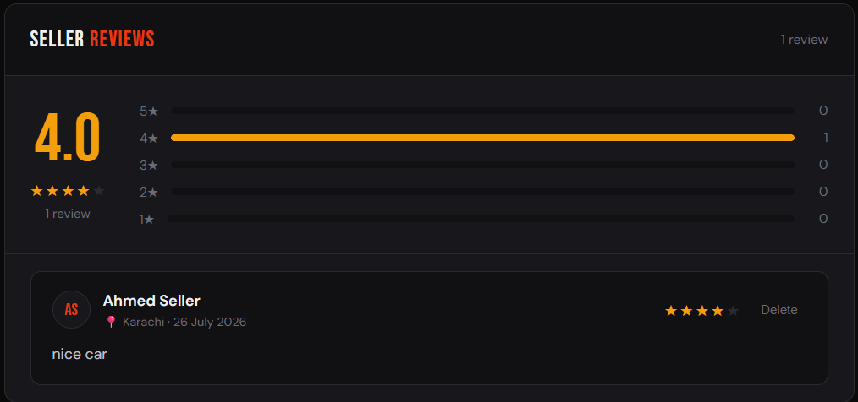
The reviews section on the vehicle detail page displays an average rating with a star distribution bar chart. Authenticated buyers can submit star ratings (1-5) with an optional comment. Selecting a star triggers an animated Canvas speedometer that visually represents the rating on a gauge from 0 to 100 MPS, accompanied by a procedurally generated engine sound effect using the Web Audio API.

7.2 Achievement of Objectives
Table 7.1 - Objectives Achievement Matrix
Objective | Target | Achieved | Notes
Secure JWT authentication with role-based access control | 3 roles fully separated | Yes | Buyer, Seller, Admin with middleware enforcement
Vehicle listing with multi-image upload | Up to 10 images per listing | Yes | Multer diskStorage with file type validation
3D vehicle preview with Three.js | Interactive GLB viewer | Yes | Preview + fullscreen with drag-rotate/zoom
Direct buyer-seller messaging | Thread-based inquiry system | Yes | Polling-based with read receipts
Seller review and star rating system | 1-5 star with comments | Yes | Speedometer animation included
Admin dashboard with analytics | Charts + user/vehicle management | Yes | Chart.js bar and donut charts
Advanced search and filter | Multi-param server-side | Yes | 6 filter params with pagination
Responsive UI | Desktop and mobile compatible | Yes | Tested at 375px to 1440px widths

7.3 Gap Resolution Assessment
Reviewing the six research gaps identified in Chapter 2 against the implemented system:
- G1 (No 3D visualization): Fully addressed with Two-context Three.js viewer (preview + fullscreen), GLTFLoader for real models, and procedural fallback car.
- G2 (No seller trust system): Fully addressed with per-seller review and star rating module, average rating display, and distribution bars.
- G3 (No centralized messaging): Fully addressed with threaded inquiry messaging system with unread tracking and conversation grouping.
- G4 (No admin approval workflow): Fully addressed with pending/approve/reject pipeline enforced at both API and frontend levels.
- G5 (Primitive search): Fully addressed with six-parameter server-side search including keyword regex, city, category, price range, sort, and pagination.
- G6 (No role separation): Fully addressed with distinct UIs and API access controls for buyer, seller, and admin roles.

7.4 Performance Evaluation
API performance measured during testing showed all read endpoints responded under 250ms for typical dataset sizes (under 1000 records), comfortably within the 500ms non-functional requirement. The POST /api/auth/login endpoint averages approximately 380ms due to bcrypt's intentional computational cost, which is acceptable and expected. POST /api/vehicles with image uploads averages 620ms, dependent on file size and disk I/O. All performance results are considered satisfactory for the FYP context.

7.5 Discussion
FourWheels successfully demonstrates that a full-featured vehicle marketplace competitive with existing Pakistani platforms can be built using a modern open-source stack within the constraints of a Final Year Project. The technical implementation quality is evidenced by clean MVC architecture, robust error handling, role-based security, and a sophisticated frontend experience using vanilla JavaScript without framework overhead.
The 3D viewer integration proved to be the most technically innovative aspect of the project. While the majority of users' vehicles will not have GLB model files, the fallback procedural car model ensures the viewer is never empty, maintaining the feature's visual impact. Future sellers could provide 3D scans of vehicles using smartphone-based photogrammetry applications.
The messaging system's polling-based approach was a pragmatic compromise. While WebSocket-based real-time chat would provide a superior user experience, the 5-second polling interval provides acceptable freshness for an inquiry system (as opposed to a live chat application) without requiring additional infrastructure.

7.6 Limitations Encountered
- File Storage: Vehicle images and 3D models are stored on the local filesystem of the server. In a production deployment, this would be replaced by a cloud object storage service (e.g., AWS S3, Cloudflare R2) for scalability and reliability.
- Real-time Messaging: The 5-second polling interval introduces up to 5 seconds of message delivery latency. A WebSocket implementation using Socket.io would eliminate this.
- Email Notifications: No email notifications are sent for events like new inquiries, account blocks, or listing approvals. This would be a critical feature for production.
- Image Optimization: Uploaded images are stored as-is without compression or resizing. A production system would use Sharp or similar libraries to generate optimized thumbnails.
- Search Limitations: The current regex-based search does not support full-text search ranking, typo tolerance, or phonetic matching. A production system might integrate Elasticsearch or MongoDB Atlas Search.

CHAPTER 8: CONCLUSION & FUTURE WORK

8.1 Conclusion
FourWheels represents a comprehensive and technically robust Final Year Project that successfully delivers Pakistan's first vehicle marketplace with integrated 3D vehicle preview technology. All eight primary objectives defined in Chapter 1 were fully achieved. The platform's implementation spans 13 development modules, encompassing backend API development in Express.js/Node.js, MongoDB data modeling, JWT-based security, Multer file management, Three.js 3D rendering, Chart.js analytics, and responsive frontend development.
The project demonstrates practical mastery of modern full-stack web development, including: RESTful API design with proper HTTP status code usage; MongoDB query optimization with compound filters and aggregation pipelines; role-based access control with middleware architecture; multi-file upload handling with file type and size validation; and interactive 3D web graphics using the Three.js library.
From a domain perspective, FourWheels bridges the significant technology gap between existing Pakistani vehicle platforms and global marketplace standards. The introduction of 3D vehicle visualization, structured seller trust through reviews, centralized messaging, and admin quality control workflows position FourWheels as a viable foundation for a production-grade marketplace product.

8.2 Limitations
Despite its completeness as an FYP, FourWheels has several limitations that would need to be addressed before commercial deployment:
- Local file storage is not suitable for production scale; cloud object storage is required.
- No automated test suite (unit or integration tests) was implemented due to time constraints.
- The frontend's single-file-per-page approach becomes harder to maintain at scale; a component framework (React, Vue) would be preferable.
- No CDN or caching layer is in place, meaning high-traffic periods could strain the single Express server.
- No email/SMS notification system limits the platform's ability to engage users outside of the browser session.

8.3 Future Enhancements
The following enhancements are proposed for future development iterations of FourWheels:

8.3.1 Short-Term Enhancements (Phase 2)
- WebSocket-based real-time messaging using Socket.io to eliminate polling latency.
- Email notification system using Nodemailer or a transactional email service (SendGrid, Mailgun) for inquiry alerts, approval notifications, and account updates.
- Cloud file storage migration to AWS S3 or Cloudflare R2 with signed URL generation for secure image and model access.
- Image optimization pipeline using Sharp.js to auto-compress and resize uploaded vehicle photos.
- Automated test suite using Jest and Supertest for backend API testing.

8.3.2 Medium-Term Enhancements (Phase 3)
- Progressive Web App (PWA) implementation with service worker caching for offline browsing of recently viewed listings.
- Full-text search using MongoDB Atlas Search for typo-tolerant, ranked vehicle search results.
- Dealer verification program with a dedicated dealer account type, verified badge, and bulk listing upload capability.
- Vehicle price estimation tool using historical listing data and machine learning regression models.
- Saved listings and search alert system allowing buyers to bookmark vehicles and receive notifications for new matching listings.

8.3.3 Long-Term Enhancements (Phase 4)
- React or Vue.js frontend migration for component reuse, state management, and improved developer experience.
- Mobile native applications (iOS and Android) using React Native, leveraging the existing REST API backend.
- Integrated vehicle financing calculator with bank API integration for instant loan eligibility checks.
- AI-powered vehicle valuation tool trained on Pakistani market pricing data.
- Augmented Reality (AR) vehicle preview using WebXR, allowing buyers to place vehicles in their physical environment.

8.4 Social Impact and Applications
FourWheels has the potential to create significant social and economic impact in Pakistan's vehicle market:
- Democratization of Vehicle Commerce: By reducing reliance on physical dealerships and informal networks, FourWheels gives individual sellers equal access to a large buyer audience, potentially leading to better pricing and faster sales.
- Buyer Protection: The seller review system, admin approval workflow, and structured listing format reduce information asymmetry and the risk of fraud that currently plagues informal vehicle trading channels.
- Technology Adoption: The introduction of 3D vehicle previews demonstrates to the local market that advanced visualization technology is achievable even for locally-developed platforms, potentially encouraging broader technology adoption in the vertical.
- Digital Literacy: The platform's clean, modern interface serves as an example of quality Pakistani software product development, contributing to the narrative of a maturing local tech industry.
- Economic Efficiency: Faster, more transparent vehicle transactions reduce the time cost for both buyers (who currently visit multiple dealers) and sellers (who currently rely on word-of-mouth and phone inquiries).

REFERENCES
1. Mongoose Documentation. (2024). Mongoose v9 ODM for MongoDB. https://mongoosejs.com/docs/
2. Three.js Documentation. (2024). Three.js r128 API Reference. https://threejs.org/docs/
3. Express.js Documentation. (2024). Express 5.x API Reference. https://expressjs.com/en/5x/api.html
4. JSON Web Token (JWT) Standard. RFC 7519. https://tools.ietf.org/html/rfc7519
5. Multer Documentation. (2024). Multer v2 - Node.js Middleware for Multipart Data. https://github.com/expressjs/multer
6. Chart.js Documentation. (2024). Chart.js v4 API Reference. https://www.chartjs.org/docs/
7. bcrypt Algorithm. Provos, N., & Mazieres, D. (1999). A Future-Adaptable Password Scheme. USENIX Annual Technical Conference.
8. MongoDB Documentation. (2024). MongoDB v7 Query and Aggregation Pipeline. https://www.mongodb.com/docs/
9. PakWheels.com. (2024). Pakistan's Largest Auto Marketplace. https://www.pakwheels.com
10. OLX Pakistan. (2024). OLX Vehicles Section. https://www.olx.com.pk/vehicles_c84
11. MDN Web Docs. (2024). Fetch API Reference. https://developer.mozilla.org/en-US/docs/Web/API/Fetch_API
12. Web Audio API. (2024). W3C Web Audio Specification. https://www.w3.org/TR/webaudio/

APPENDIX

Appendix A - Installation and Setup Guide

A.1 Prerequisites
- Node.js v20 or higher installed
- MongoDB v7.x running locally or a MongoDB Atlas connection string
- Git installed for cloning the repository

A.2 Installation Steps
- Clone the repository: git clone https://github.com/saffomian5115/FourWheels.git
- Navigate to backend: cd FourWheels/backend
- Install dependencies: npm install
- Create .env file in root directory with MONGO_URI, JWT_SECRET, and PORT=5000
- Seed sample data (optional): node backend/scripts/seedData.js
- Start the server: npm run dev
- Open frontend/index.html in browser or use Live Server

A.3 Test Accounts (After Seeding)
- Admin: admin@fourwheels.pk / password123
- Seller: ahmed@fourwheels.pk / password123
- Seller: sara@fourwheels.pk / password123
- Buyer: ali@fourwheels.pk / password123

Appendix B - API Endpoint Reference
A complete API endpoint reference is provided in Chapter 4, Tables 4.3 through 4.7. All endpoints use the base URL http://localhost:5000/api and return JSON responses. Protected endpoints require the header: Authorization: Bearer <JWT_TOKEN>.

Appendix C - Database Schema Reference
Complete Mongoose schema definitions are located in the backend/models/ directory. The four schemas are: User.js, Vehicle.js, Message.js, and Review.js. Each schema includes field-level validation rules, default values, and TypeScript-compatible type definitions via Mongoose's Schema class.

